Supplemental Material

Title: Dietary manganese, plasma markers of inflammation, and the development of type 2 diabetes in postmenopausal women: findings from the Women’s Health Initiative

Jung Ho Gong*, jung_ho_gong@brown.edu^{1,2}, Kenneth Lo*ª, PhD, kenneth_lo@brown.edu¹⁻³, Qing Liu, PhD, qing_liu@brown.edu^{1,2}, Jie Li, PhD, jie_li@brown.edu¹⁻³, Shuiqing Lai, MD, lai_shuiqing@brown.edu¹⁻³, Aladdin H. Shadyab, PhD, aladdinhs@yahoo.com⁴, Chrisa Arcan, hrisanti.arcan@stonybrookmedicine.edu⁵, PhD, Linda Snetselaar, PhD, linda-snetselaar@uiowma.edu⁶, Simin Liu, MD, ScD, simin_liu@brown.edu^{1,2,7}

* JG, KL contributed equally to this paper.

Address of each author:
1: Department of Epidemiology, Brown University, Providence, RI, USA; 2: Centre for Global Cardiometabolic Health, Brown University, Providence, RI, USA; 3: Department and Cardiology, Guangdong Cardiovascular Institute, Hypertension Research Laboratory, Guangdong Provincial People's Hospital, Guangdong Provincial Key Laboratory of Coronary Heart Disease Prevention, Guangdong Academy of Medical Sciences, South China University of Technology School of Medicine, Guangzhou, China; 4: Department of Family Medicine and Public Health, University of California San Diego School of Medicine, La Jolla, CA, USA; 5: Department of Family, Population, and Preventive Medicine, Medical School, Stony Brook University, HSC L3, Room 086, Stony Brook, NY, USA; 6: Department of Epidemiology, University of Iowa College of Public Health, Iowa City, IA, USA; 7: Hallett Center for Diabetes and Endocrinology, Rhode Island Hospital, Warren Alpert Medical School of Brown University, Providence, RI

Correspondence to:
Prof. Simin Liu, Centre for Global Cardiometabolic Health and Departments of Epidemiology, Medicine, and Surgery, Brown University, Providence, Rhode Island, USA

Supplemental Figure 1 Selection of study population for the main analysis
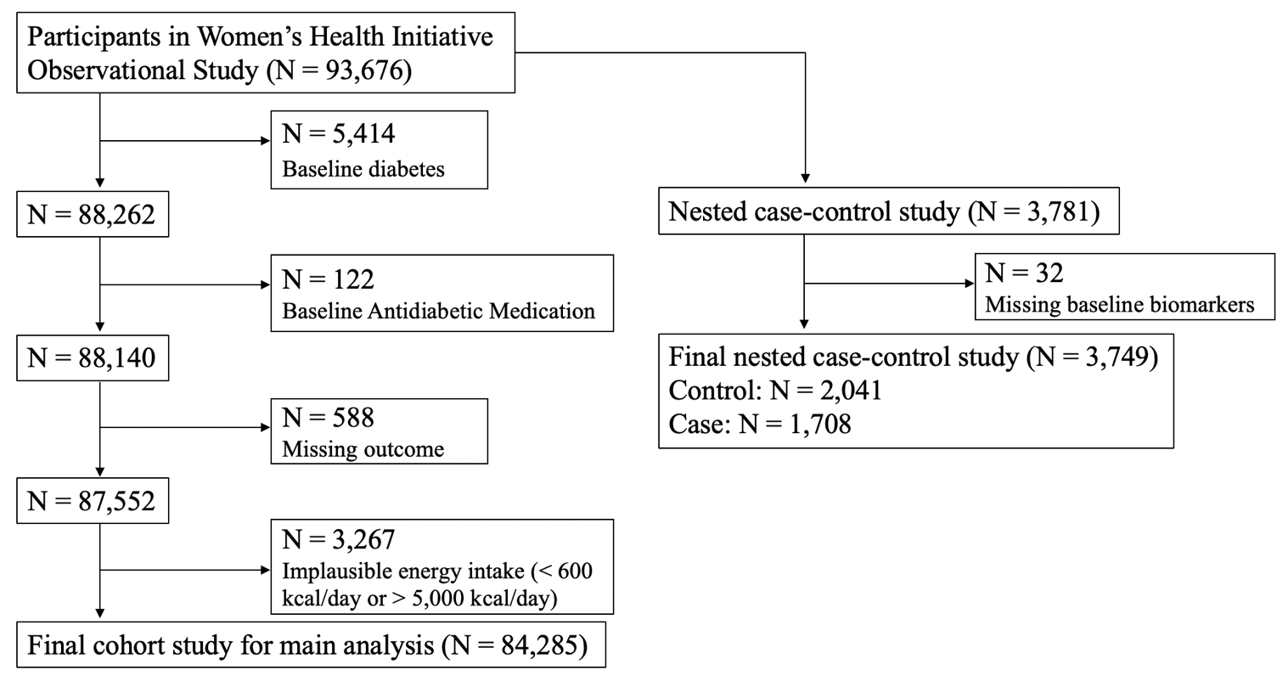

Supplemental Figure 2 Selection of study population for the replication analysis
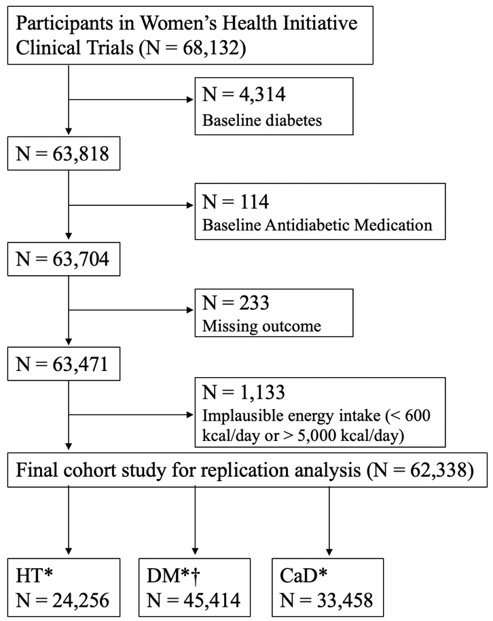
* Out of 62,452 Women’s Health Initiative Clinical Trial participants selected for the replication analysis, 24,256 participated in the Hormone Therapy (HT) Trial, 45,414 participated in the Dietary Modification (DM) Trial, and 33,458 participated in the Calcium-Vitamin D (CaD) Trial.
† 16,924 Women’s Health Initiative Clinical Trial participants were not randomized to the DM. Among the DM participants, 18,182 received dietary intervention; 27,232 were controls.
Supplemental Table 1 Baseline characteristics according to quintiles of energy-adjusted dietary manganese among 62,338 postmenopausal women aged 50-79 enrolled in the Women’s Health Initiative Clinical Trial
 | Energy-adjusted dietary manganese
 | Quintile 1 | Quintile 2 | Quintile 3 | Quintile 4 | Quintile 5 | P value||
N | 12450 | 12472 | 12464 | 12471 | 12481
Person-year | 134076 | 140066 | 142261 | 144812 | 146167
Participants with type 2 diabetes (%) | 1913 (15.4 %) | 1528 (12.3 %) | 1327 (10.6 %) | 1198 (9.6 %) | 1105 (8.9 %)
Manganese intake (mg/day) * | 2.17 ± 0.94 | 2.4 ± 0.85 | 2.89 ± 0.82 | 3.48 ± 0.83 | 4.8 ± 1.22
Age (years) | 62 ± 7 | 62 ± 7 | 63 ± 7 | 63 ± 7 | 63 ± 7 | <0.001
Race/ethnicity |  |  |  |  |  | <0.001
White | 8968 (72 %) | 9994 (80.1 %) | 10563 (84.7 %) | 10914 (87.5 %) | 11350 (90.9 %)
Black | 2083 (16.7 %) | 1396 (11.2 %) | 954 (7.7 %) | 805 (6.5 %) | 561 (4.5 %)
Hispanic | 1020 (8.2 %) | 557 (4.5 %) | 404 (3.2 %) | 278 (2.2 %) | 196 (1.6 %)
Region |  |  |  |  |  | <0.001
Northeast | 2744 (22 %) | 2896 (23.2 %) | 3005 (24.1 %) | 2937 (23.6 %) | 2776 (22.2 %)
South | 3787 (30.4 %) | 3284 (26.3 %) | 2968 (23.8 %) | 2847 (22.8 %) | 2827 (22.7 %)
Midwest | 2773 (22.3 %) | 2685 (21.5 %) | 2657 (21.3 %) | 2777 (22.3 %) | 2889 (23.1 %)
West | 3146 (25.3 %) | 3607 (28.9 %) | 3834 (30.8 %) | 3910 (31.4 %) | 3989 (32 %)
Income (US dollars) |  |  |  |  |  | <0.001
<20,000 | 2678 (21.5 %) | 2135 (17.1 %) | 1884 (15.1 %) | 1780 (14.3 %) | 1715 (13.7 %)
20,000-49,999 | 5704 (45.8 %) | 5666 (45.4 %) | 5691 (45.7 %) | 5636 (45.2 %) | 5642 (45.2 %)
50,000-99,999 | 2998 (24.1 %) | 3475 (27.9 %) | 3606 (28.9 %) | 3635 (29.1 %) | 3696 (29.6 %)
>100,000 | 699 (5.6 %) | 893 (7.2 %) | 1018 (8.2 %) | 1120 (9 %) | 1173 (9.4 %)
Highest education |  |  |  |  |  | <0.001
High school | 3782 (30.4 %) | 3101 (24.9 %) | 2834 (22.7 %) | 2519 (20.2 %) | 2290 (18.3 %)
Vocational/training school | 1522 (12.2 %) | 1414 (11.3 %) | 1228 (9.9 %) | 1250 (10 %) | 1197 (9.6 %)
College | 4627 (37.2 %) | 4938 (39.6 %) | 5059 (40.6 %) | 5018 (40.2 %) | 5012 (40.2 %)
Post-graduate | 2519 (20.2 %) | 3019 (24.2 %) | 3343 (26.8 %) | 3684 (29.5 %) | 3982 (31.9 %)
BMI (kg/m²) | 30.3 ± 6.3 | 29.1 ± 5.8 | 28.4 ± 5.6 | 28 ± 5.4 | 27.5 ± 5.3 | <0.001
Systolic blood pressure (mmHg) | 128.7 ± 17.1 | 127.8 ± 17.2 | 127.4 ± 17.3 | 127.1 ± 17.3 | 126.4 ± 17.4 | <0.001
Physical Activity (METs-hr/week) | 8.1 ± 11.2 | 9.5 ± 11.6 | 10.7 ± 12.3 | 11.8 ± 12.9 | 13.4 ± 13.9 | <0.001
Total energy intake (kcal/day) | 1916 ± 820 | 1585 ± 642 | 1622 ± 617 | 1686 ± 611 | 1875 ± 638 | 0.27
Alcohol consumption (g/day) | 3.3 ± 8.8 | 3.3 ± 6.9 | 4.1 ± 7.1 | 5.1 ± 8 | 8.9 ± 14.5 | <0.001
Smoking status |  |  |  |  |  | <0.001
Never smoked | 6719 (54 %) | 6593 (52.9 %) | 6392 (51.3 %) | 6237 (50 %) | 5835 (46.8 %)
Past smoker | 4535 (36.4 %) | 4858 (39 %) | 5183 (41.6 %) | 5299 (42.5 %) | 5709 (45.7 %)
Current smoker | 1196 (9.6 %) | 1021 (8.2 %) | 889 (7.1 %) | 935 (7.5 %) | 937 (7.5 %)
Hormone therapy usage at baseline |  |  |  |  |  | <0.001
Never used hormones | 4876 (39.2 %) | 4540 (36.4 %) | 4393 (35.2 %) | 4394 (35.2 %) | 4734 (37.9 %)
Past user | 3135 (25.2 %) | 3094 (24.8 %) | 3116 (25 %) | 3215 (25.8 %) | 3378 (27.1 %)
Current user | 4439 (35.7 %) | 4838 (38.8 %) | 4955 (39.8 %) | 4862 (39 %) | 4369 (35 %)
Diabetes family history |  |  |  |  |  | <0.001
Yes | 4236 (34 %) | 4000 (32.1 %) | 3938 (31.6 %) | 3700 (29.7 %) | 3678 (29.5 %)
No | 7437 (59.7 %) | 7889 (63.3 %) | 7948 (63.8 %) | 8264 (66.3 %) | 8285 (66.4 %)
Use of antihypertensive medication |  |  |  |  |  | <0.001
Yes | 1448 (11.6 %) | 1298 (10.4 %) | 1249 (10 %) | 1159 (9.3 %) | 965 (7.7 %)
No | 11002 (88.4 %) | 11174 (89.6 %) | 11215 (90 %) | 11312 (90.7 %) | 11516 (92.3 %)
CAD arm† |  |  |  |  |  | <0.001
Not randomized | 6008 (48.3 %) | 5878 (47.1 %) | 5656 (45.4 %) | 5689 (45.6 %) | 5649 (45.3 %)
Intervention | 3262 (26.2 %) | 3251 (26.1 %) | 3434 (27.6 %) | 3412 (27.4 %) | 3401 (27.2 %)
Control | 3180 (25.5 %) | 3343 (26.8 %) | 3374 (27.1 %) | 3370 (27 %) | 3431 (27.5 %)
DM arm‡ |  |  |  |  |  | <0.001
Not randomized | 2750 (22.1 %) | 2732 (21.9 %) | 3044 (24.4 %) | 3620 (29 %) | 4778 (38.3 %)
Intervention | 3907 (31.4 %) | 3861 (31 %) | 3782 (30.3 %) | 3543 (28.4 %) | 3089 (24.7 %)
Control | 5793 (46.5 %) | 5879 (47.1 %) | 5638 (45.2 %) | 5308 (42.6 %) | 4614 (37 %)
HRT arm§ |  |  |  |  |  | <0.001
Not randomized | 7851 (63.1 %) | 8168 (65.5 %) | 7946 (63.8 %) | 7543 (60.5 %) | 6574 (52.7 %)
E-only intervention | 1012 (8.1 %) | 875 (7 %) | 878 (7 %) | 854 (6.8 %) | 939 (7.5 %)
E-only control | 1022 (8.2 %) | 872 (7 %) | 847 (6.8 %) | 906 (7.3 %) | 1007 (8.1 %)
E+P intervention | 1301 (10.4 %) | 1327 (10.6 %) | 1426 (11.4 %) | 1619 (13 %) | 2024 (16.2 %)
E+P control | 1264 (10.2 %) | 1230 (9.9 %) | 1367 (11 %) | 1549 (12.4 %) | 1937 (15.5 %)

Continuous variables are presented as mean ± SD.
Categorical variables are presented as mean (%). Categorical variables may not add up to 100% due to missing or unknown information.
* Energy-unadjusted dietary manganese intake estimated from WHI FFQ
† Calcium and Vitamin D Trial arm
‡ Diet Modification Trial arm
§ Hormone Therapy Trial arm (E: estrogen, P: progestin)
|| Chi-square test was used to compare proportions/frequencies for categorical variables. One-way ANOVA was used to compare means for continuous variables.
Supplemental Table 2 Hazard ratios with 95% CIs of type 2 diabetes according to quintiles of energy-adjusted dietary manganese among 62,338 postmenopausal women aged 50-79 enrolled in the Women’s Health Initiative Clinical Trial
 | Energy-adjusted dietary manganese
Model | Quintile 1 | Quintile 2 | Quintile 3 | Quintile 4 | Quintile 5 | P for trend
Model 1* | 1.00 | 0.80 (0.74, 0.85) | 0.70 (0.65, 0.75) | 0.63 (0.58, 0.67) | 0.58 (0.54, 0.63) | <0.001
Model 2† | 1.00 | 0.82 (0.77, 0.88) | 0.72 (0.67, 0.77) | 0.64 (0.59, 0.69) | 0.59 (0.54, 0.63) | <0.001
Model 3‡ | 1.00 | 0.87 (0.81, 0.93) | 0.79 (0.74, 0.85) | 0.73 (0.68, 0.79) | 0.72 (0.67, 0.78) | <0.001
Model 4§ | 1.00 | 0.89 (0.83, 0.96) | 0.84 (0.78, 0.90) | 0.78 (0.73, 0.85) | 0.79 (0.73, 0.85) | <0.001
Model 5¶ | 1.00 | 0.89 (0.83, 0.96) | 0.84 (0.78, 0.90) | 0.78 (0.73, 0.85) | 0.79 (0.73, 0.85) | <0.001

* Model 1 was adjusted for age and race/ethnicity.
† Model 2 was adjusted for age, race/ethnicity, and total energy intake.
‡ Model 3 was adjusted for age, race/ethnicity, total energy intake, region of residence at baseline, family income, education, smoking status, alcohol intake, systolic blood pressure, physical activity, family diabetes history, hormone usage, and use of antihypertensive medication.
§ Model 4 was adjusted for age, race/ethnicity, total energy intake, region of residence at baseline, family income, education, smoking status, alcohol intake, systolic blood pressure, physical activity, family diabetes history, hormone usage, use of antihypertensive medication, and BMI.
¶ Model 5 was adjusted for age, race/ethnicity, total energy intake, region of residence at baseline, family income, education, smoking status, alcohol intake, systolic blood pressure, physical activity, family diabetes history, hormone usage, use of antihypertensive medication, BMI, Hormone Therapy Trial treatment, Diet Modification Trial treatment, and Calcium-Vitamin D Trial treatment.
Supplemental Table 3 Hazard ratios with 95% CIs of type 2 diabetes according to quintiles of energy-adjusted dietary manganese among 75,753 postmenopausal women aged 50-79 without missing covariates enrolled in the Women’s Health Initiative Observational Study
Model | Energy-adjusted dietary manganese |  |  |  |  | P for trend
 | Quintile 1 | Quintile 2 | Quintile 3 | Quintile 4 | Quintile 5
Model 1* | 1.00 | 0.74 (0.69, 0.79) | 0.62 (0.58, 0.67) | 0.50 (0.46, 0.54) | 0.46 (0.42, 0.50) | <0.001
Model 2† | 1.00 | 0.78 (0.73, 0.84) | 0.66 (0.61, 0.71) | 0.53 (0.49, 0.57) | 0.46 (0.43, 0.50) | <0.001
Model 3‡ | 1.00 | 0.86 (0.80, 0.92) | 0.77 (0.71, 0.83) | 0.65 (0.60, 0.70) | 0.61 (0.56, 0.67) | <0.001
Model 4§ | 1.00 | 0.92 (0.85, 0.99) | 0.84 (0.78, 0.91) | 0.72 (0.66, 0.78) | 0.70 (0.64, 0.76) | <0.001

* Model 1 was adjusted for age and race/ethnicity.
† Model 2 was adjusted for age, race/ethnicity, and total energy intake.
‡ Model 3 was adjusted for age, race/ethnicity, region of residence at baseline, family income, education, total energy intake, smoking status, alcohol intake, systolic blood pressure, physical activity, family diabetes history, hormone usage, and use of antihypertensive medication.
§ Model 4 was adjusted for age, race/ethnicity, total energy intake, region of residence at baseline, family income, education, smoking status, alcohol intake, systolic blood pressure, physical activity, family diabetes history, hormone usage, use of antihypertensive medication, and BMI.

Supplemental Table 4 Hazard ratios with 95% CIs of type 2 diabetes according to quintiles of energy-adjusted dietary manganese among 84,285 postmenopausal women aged 50-79 stratified by race/ethnicity
 | Energy-adjusted dietary manganese
Race/ethnicity | Quintile 1 | Quintile 2 | Quintile 3 | Quintile 4 | Quintile 5 | P for trend
White (N = 72,226) | 1.00 | 0.94 (0.86, 1.01) | 0.84 (0.77, 0.91) | 0.73 (0.67, 0.8) | 0.72 (0.65, 0.78) | <0.001
Black (N = 5,713) | 1.00 | 0.98 (0.82, 1.17) | 0.94 (0.76, 1.16) | 0.83 (0.65, 1.05) | 0.67 (0.51, 0.89) | 0.005
Hispanic (N = 2,859) | 1.00 | 0.69 (0.51, 0.94) | 0.67 (0.47, 0.96) | 0.62 (0.40, 0.95) | 0.84 (0.53, 1.33) | 0.03

All models were adjusted for age, total energy intake, region of residence at baseline, family income, education, smoking status, alcohol intake, systolic blood pressure, physical activity, family diabetes history, hormone usage, use of antihypertensive medication, and BMI.

Supplemental Table 5 Hazard ratios with 95% CIs of type 2 diabetes according to quintiles of dietary manganese and total manganese intake among 84,285 postmenopausal women aged 50-79 enrolled in the Women’s Health Initiative Observational Study
 | Energy-unadjusted dietary manganese
Model | Quintile 1 | Quintile 2 | Quintile 3 | Quintile 4 | Quintile 5 | P for trend
Model A | 1.00 | 0.87 (0.81, 0.93) | 0.75 (0.70, 0.82) | 0.71 (0.66, 0.78) | 0.63 (0.57, 0.70) | <0.001
 | Total manganese intake*
 | Quintile 1 | Quintile 2 | Quintile 3 | Quintile 4 | Quintile 5
Model B | 1.00 | 0.85 (0.79, 0.92) | 0.77 (0.71, 0.83) | 0.70 (0.65, 0.76) | 0.63 (0.57, 0.69) | <0.001

Both models were adjusted for age, race/ethnicity, total energy intake, region of residence at baseline, family income, education, smoking status, alcohol intake, systolic blood pressure, physical activity, family diabetes history, hormone usage, use of antihypertensive medication, and BMI.
* Total manganese intake was calculated by adding energy-unadjusted dietary manganese and supplemental manganese intake

Supplemental Table 6 Hazard ratios with 95% CIs of type 2 diabetes according to quintiles of energy-adjusted dietary manganese among postmenopausal women enrolled in the Women’s Health Initiative Clinical Trial stratified by the Diet Modification Trial status (not randomized, dietary intervention, or clinical trial control)
 | Energy-adjusted dietary manganese
Population | Quintile 1 | Quintile 2 | Quintile 3 | Quintile 4 | Quintile 5 | P for trend
Not randomized (N = 16,924) | 1.00 | 0.81 (0.69, 0.94) | 0.86 (0.74, 1.00) | 0.80 (0.69, 0.92) | 0.77 (0.67, 0.89) | <0.001
Dietary intervention (N = 18,182) | 1.00 | 0.97 (0.86, 1.11) | 0.85 (0.75, 0.98) | 0.80 (0.70, 0.92) | 0.84 (0.73, 0.98) | <0.001
Clinical trial control (N = 27,232) | 1.00 | 0.88 (0.80, 0.98) | 0.81 (0.73, 0.90) | 0.78 (0.69, 0.87) | 0.76 (0.68, 0.86) | <0.001

All three models were adjusted for age, race/ethnicity, total energy intake, region of residence at baseline, family income, education, smoking status, alcohol intake, systolic blood pressure, physical activity, family diabetes history, hormone usage, use of antihypertensive medication, BMI, Hormone Therapy Trial treatment, Diet Modification Trial treatment, and Calcium-Vitamin D Trial treatment.

Supplemental Table 7 Adjusted estimation of relative levels of biomarkers according to quintiles of energy-adjusted dietary manganese among 3,749 postmenopausal women enrolled in the nested case-control study
 | Energy-adjusted dietary manganese
Biomarkers | Quintile 1 | Quintile 2 | Quintile 3 | Quintile 4 | Quintile 5 | P for trend
Fasting glucose | 1.00 | 0.98 (0.95, 1.00) | 0.97 (0.95, 1.00) | 0.96 (0.94, 0.99) | 0.94 (0.92, 0.97) | <0.001
Fasting insulin | 1.00 | 0.93 (0.88, 0.99) | 0.89 (0.84, 0.95) | 0.89 (0.84, 0.94) | 0.84 (0.79, 0.89) | <0.001
HOMA-IR | 1.00 | 0.91 (0.85, 0.98) | 0.87 (0.81, 0.93) | 0.86 (0.80, 0.92) | 0.79 (0.74, 0.85) | <0.001
HOMA-Beta | 1.00 | 0.98 (0.92, 1.05) | 0.96 (0.90, 1.02) | 0.97 (0.90, 1.03) | 0.96 (0.89, 1.02) | 0.20
VCAM1* | 1.00 | 1.00 (0.97, 1.04) | 1.00 (0.96, 1.03) | 1.01 (0.97, 1.04) | 0.96 (0.93, 0.99) | 0.04
TNFR2† | 1.00 | 1.00 (0.97, 1.03) | 0.99 (0.96, 1.02) | 0.98 (0.95, 1.02) | 0.95 (0.92, 0.98) | 0.002
IL6‡ | 1.00 | 0.93 (0.86, 1.01) | 0.92 (0.85, 0.99) | 0.86 (0.79, 0.93) | 0.85 (0.78, 0.92) | <0.001
hsCRP§ | 1.00 | 0.96 (0.86, 1.07) | 0.91 (0.82, 1.02) | 0.90 (0.81, 1.01) | 0.81 (0.73, 0.91) | <0.001

Models were adjusted for age, race/ethnicity, total energy intake, region of residence at baseline, family income, education, smoking status, alcohol intake, systolic blood pressure, physical activity, family diabetes history, hormone usage, use of antihypertensive medication, and BMI.
*VCAM1: Vascular cell adhesion molecule 1
† TNFR2: Tumor necrosis factor receptor 2
‡ IL6: interleukin 6
§ hsCRP: high-sensitivity C-reactive protein

