Empagliflozin ameliorates obesity-related cardiac dysfunction by regulating Sestrin2-mediated AMPK-mTOR signaling and redox homeostasis in high-fat induced obese mice

Xiaodong Sun, Fang Han, Qingguo Lu, Xuan Li, Di Ren, Jingwen Zhang, Ying Han,
Yang K. Xiang, Ji Li

Supplemental Material
Body composition analysis
Body composition of the mice were measured by EchoMRI body composition analyser (EchoMRI LLC, Houston, USA).
Oral glucose tolerance test (OGTT) and insulin tolerance test (ITT)
After a 6h fasting, the mice were given glucose (2 mg/g) via an oral gavage or humulin (0.75 U/kg) intraperitoneally, respectively. Blood glucose levels were measured by tail vein puncture with a blood glucometer (AimStrip Plus, USA) at the different time point (0, 30, 60, 90 and 120 min).
Biochemical Analysis
The mice were anesthetized with 3% isolurane and blood was collected from heart. Blood was centrifuged and plasma was stored at −80 °C until determination. Plasma lipids were measured by. Fasting insulin levels were measured with a mouse insulin ELISA kit. Plasma FFA levels were measured with a using colorimetric assays (BioVision, USA, Cat. #K612-100). Plasma adiponectin and leptin levels were measured using ELISA kits (R&D, Cat. #MRP300 and #MOB00).

Western blotting
The primary antibodies are as followings: p-AMPK (Thr¹⁷²) (#2535), AMPKα (#5831), p-mTOR (#2971), mTOR (#2972s), Nrf2 (#12721), HO-1(#70081), MCP-1 (#2027), p-NF-κB-p65 (#3033), p-p70 S6 kinase (#9205S), PI3K p110α (#4249), p-Akt (Ser⁴⁷³) (#4060) and Akt (#4691) were purchased from Cell Signalling Tech (USA); p-eNOS (Ser¹¹⁷⁷) (#ab215717), eNOS (#ab199956) were obtained from Abcam (USA)；Sestrin2 (#10795) was purchased from Proteintech (USA).
RNA extraction and qRT-PCR
Primer sequence used for qPCR as follows:
Primer | Forward | Reverse
GAPDH | GGTTGTCTCCTGCGACTTCA | TGGTCCAGGGTTTCTTACTCC
mtDNA | CCGCAAGGGAAAGATGAAAGA | TCGTTTGGTTTCGGGTTTC
Sesn2 | GCCTTCCGAAGTCTTGGTCAGTG | AGCCTCTGGATCAGCGAGTAGC
Nrf2 | CTGTGCTGCCAGAGGTCCTTAATG | GGAACAGTGAGGTGCCAGTAACG
Postn | GCCCTCCACTCCCTTCCTGAC | GGATGCTGATGCCTTCTTGAGACC
FSP-1 | GTGGGTCCTGCCTGTGTATTGC | AGGTGGTTCATTGTGGTTCCGTAC
HO-1 | CCTGCTGATTCTCCTCTCCTCCTC | AAGCCTTCTCTGGACACCTGACC
Catalase | TTGGTGCCTTGGTCACTGTGTTAG | GACTGGAATGCTTCGTGGCTCTC
GCLM | CTGGCTGTCCTGGAACTCACTTTG | GAGGCGGAGGCAGAGGTAGAG

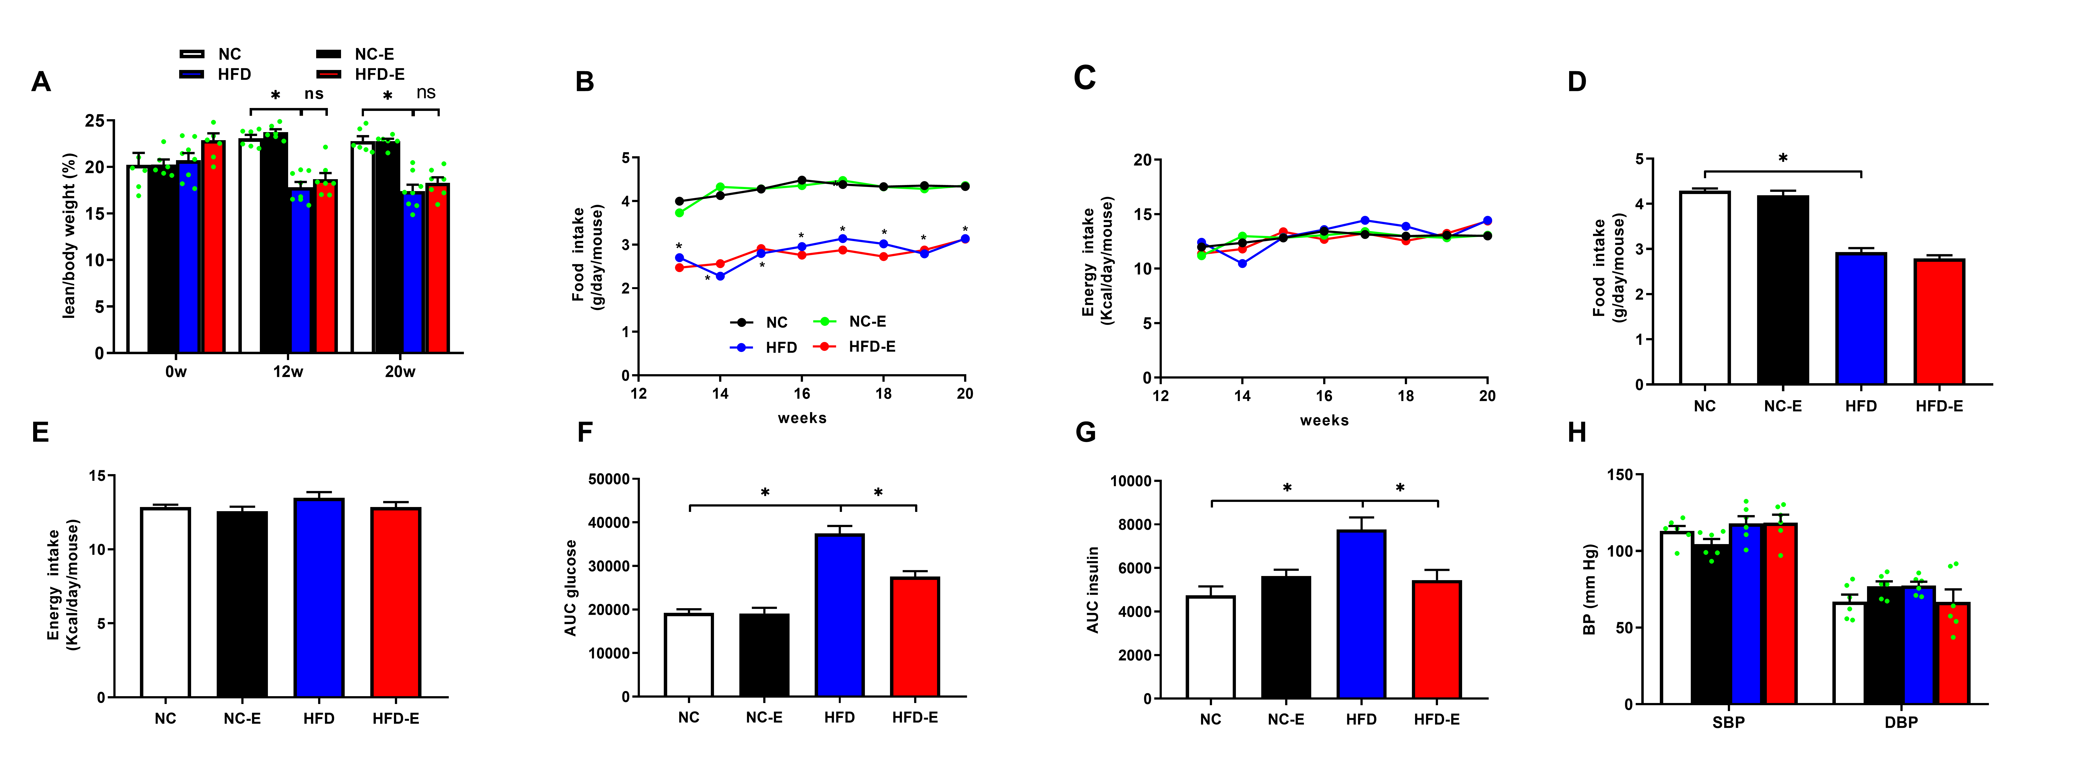Supplemental Figure 1. Effects of EMPA treatment on body weight, body composition and biochemical parameters. (A) Body lean/body weight (n=6-8/group); (B) Weekly food intake (n=5/group); (C) Weekly energy intake (n=5/group); (D) Average food intake each day (n=5/group); (E) Average energy intake each day (n=5/group); (F) glucose AUC from OGTT (n=5/group); (G) glucose AUC from ITT (n=5/group); (H) blood pressure (n=6/group)；*p<0.05.

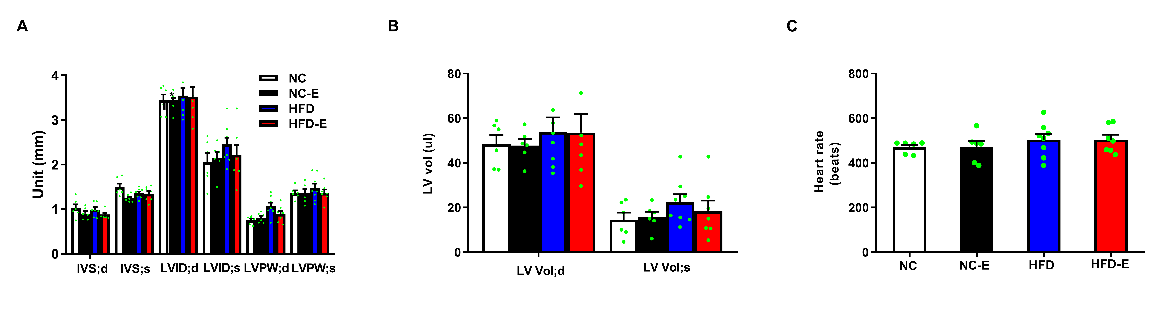

Supplemental Figure 2. Effects of EMPA treatment on cardiac function. (A) Interventricular septal (IVS) dimensions, LV internal dimensions (LVID), LV posterior wall thickness (LVPW); (B) LV volume (LV vol); (C) Heart rates. n= 6-8/group.

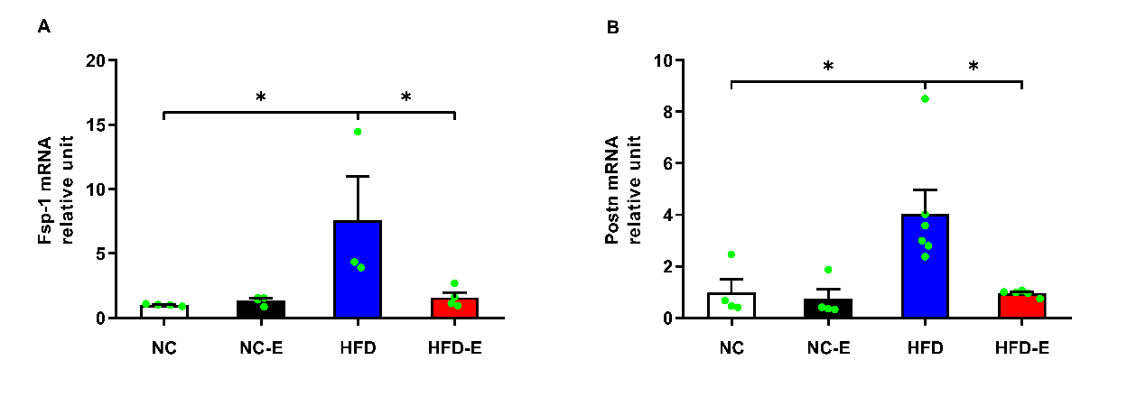
Supplemental Figure 3. Effects of EMPA treatment on Fsp-1 (A) and Postn (B). n=3-6/group. *p<0.05.
Supplemental Figure 4. Effects of EMPA treatment on phosphorylation of acetyl coenzyme A carboxylase (ACC). n=3/group. *p<0.05.
Supplemental Figure 5. Effects of EMPA treatment on mTOR, Nrf2/HO-1 and NF-κB p65 activity in isolated cardiomyocytes from HFD mice. n=3/group. *p<0.05.

