SUPPLEMENTARY MATERIAL
Use of glucagon-like peptide-1-receptor-agonists and risk of serious renal events: Scandinavian cohort study
Pasternak et al.

Data sources
Data on filled prescriptions was obtained from the national prescription registers in Sweden,¹ Denmark² and Norway^{3,4}. The registers hold individual-level information on all drug prescriptions filled at all pharmacies in the country since July, 2005, in Sweden, 1995 in Denmark, and 2004 in Norway. The registers provide the anatomical therapeutic chemical (ATC) code of the dispensed drug and information about the amount of drug dispensed, and the date when the prescription was filled.
The national patient register in each of the countries contains individual-level information on outpatient and emergency department visits and inpatient admissions to all public hospitals and private specialist care.^{5–7} We used physician-assigned procedure codes, and diagnoses according to the International Classification of Diseases, tenth revision (ICD10), to obtain information about history of disease at cohort entry for each patient and the outcome events during the study period. Information about outcome events was also obtained from Cause of Death registers in each country which includes data on the date and cause of death based on death certificates.^{8–10}
From each country’s population registers we obtained information on age, sex, country of birth, migration status, civil status (Norway) and vital status of the patients included in the study.^{11–13} From Statistics Denmark and Statistics Sweden¹¹ we obtained data on patients’ educational level and civil status.
The National Diabetes Register includes data on risk factors in patients with type 1 or type 2 diabetes in Sweden. The data are collected by trained nurses and physicians during patient visits to primary care and outpatient clinics nationwide. The number of patients who have been included in the register has increased over time; at present, over 90% of all patients receiving drugs for diabetes in Sweden are included.¹⁴ For patients living in Sweden, we used this register to obtain information on glycated hemoglobin, blood pressure, albuminuria, estimated glomerular filtration rate (eGFR), body-mass index and smoking.
Using the personal identification number assigned to all inhabitants in the three countries, we linked individual-level information between these sources of data.
Category | ATC definition | Estimated days of supply Sweden | Estimated days of supply Denmark | Estimated days of supply Norway
GLP1-receptor-agonists | A10BJ01, A10BJ02 (not including saxenda -product no. 131577 or 395175 in Denmark and Norway and 513490 in Sweden), A10BJ03, A10BJ05, A10AE56 | A10BJ01; 5 or 10 microgram = 0.5 per dose  A10BJ01; 2 mg = 7.0 per dose  A10BJ02 = 5.0 per ml  A10BJ03 = 1.0 per dose  A10BJ05 = 7.0 per dose  A10AE56 = 3.0 per ml | A10BJ01; 5 or 10 microgram = 0.5 per dose  A10BJ01; 2 mg = 7.0 per dose  A10BJ02 = 15.0 per pen  A10BJ03 = 14.0 per pen  A10BJ05 = 7.0 per dose  A10AE56 = not available | A10BJ01; 5 or 10 microgram = 0.5 per dose  A10BJ01; 2 mg = 7.0 per pen  A10BJ02 = 5.0 per ml  A10BJ03 = 1.0 per dose  A10BJ05 = 7.0 per pen  A10AE56 = 3.0 per ml
DPP4 inhibitors | A10BH01,  A10BH02,  A10BH03,  A10BH04,  A10BH05,  A10BD07,  A10BD08,  A10BD09,  A10BD10,  A10BD11,  A10BD13,  A10BD19,  A10BD21 | All units are days per tablet  A10BH01 = 1.0  A10BH02 = 0.5  A10BH03 = 1.0  A10BH04 = 1.0  A10BH05 = 1.0  A10BD07 = 0.5  A10BD08 = 0.5  A10BD09 = 1.0  A10BD10 = 0.5  A10BD11 = 0.5  A10BD13 = 0.5  A10BD19 = 1.0  A10BD21 = 1.0 | As in Sweden | As in Sweden
Supplementary Table 1 ATC codes and estimated days of exposure per unit of GLP1-receptor-agonists and DPP4 inhibitors.

Supplementary Table 2 ICD10 and procedure codes for exclusion criteria.
Category | Codes (ICD-10, procedure, or ATC)
Dialysis or renal transplantation at any time before index dateª | ICD-10: Z49, Z94.0, Z99.2  Procedure: KAS  Additional procedure codes:^{b}  Sweden: DR012, DR013, DR014, DR015, DR016, DR023, DR024, DR055, DR056, DR060, DR061  Denmark: (B)JFD, (B)JFZ
Endstage illness (severe malnutrition, cachexia, dementia, coma) at any time before index dateª | ICD-10: E40-E43, F00-F03, G30, R40.2^{b}, R64  ATC: N06D
Drug misuse within last year | ICD-10: F11-F16, F18, F19, R78.1-R78.5^{b} T40^{b} ATC: N07BB, N07BC
Major pancreatic disease (chronic pancreatitis [defined by pancreatic enzyme substitution prescription within last year or diagnosis at any time before index date], pancreatic cancer, major pancreatic surgery at any time before index dateª) | ICD-10: C25, K86.0, K86.1  Procedure: JLC, JLE  ATC: A09AA02
No specialist care contact or prescription drug in last year prior to the index date | n.a.
Hospital admission within 30 days before index date | n.a.
Liraglutide with obesity indication (Saxenda) at any time before index date | Drug product number:  Denmark: 131577, 395175  Norway: n.a.  Sweden: 513490

Abbreviations: ICD, International Classification of Diseases; ATC, Anatomical Therapeutic Chemical
ª 10-year lookback in Sweden and Denmark; 2 years look-back in Norway
^{b} Not available in the Norwegian dataset.

Supplementary Table 3 Propensity score variables and definitions.

Sociodemographic characteristics | ICD/categories
Sex | Women; men
Age | 5-year categories
Educationª | Primary school; high school; vocational or short tertiary education; medium or long tertiary education
Place of birth | Scandinavia^{b}; Rest of Europe; Outside Europe, Missing
Living with partner | Yes; no
Medical history^{c} | ICD-10 codes and procedure codes
Acute coronary syndrome | ICD-10: I200, I21-22
Other ischemic heart disease | ICD-10: I11 (not I110), I20 (not I200), I24, I25
Heart failure/cardiomyopathy | ICD-10: I50, I110, I130, I132, I42, I43, J81
Valve disorders | ICD-10: I34-I37
Stroke | ICD-10: I60-I64
Other cerebrovascular disease | ICD-10: I65-I69, G45 (excl G454), G46
Atrial fibrillation | ICD-10: I48
Other arrhythmia | ICD-10: I44-I47, I49
Arterial disease (including amputation) | ICD-10: I65, I70, I72, I73, I74, I77, K550, K551, E115, E145, E135  Procedure: NFQ, NGQ, NHQ
Chronic kidney disease | ICD-10: E112, E142, I120, I131, I132, N18, N19
Other renal disease | ICD-10: N00-08, N10-N16, N17, N20-N23, N25-N29
Diabetes complications | ICD-10: E110, E111, E113, E114, E116, E117, E118, E130, E131, E133, E134, E136, E137, E138, E140, E141, E143, E144, E146, E147, E148, E160, E161, E162, G990, G590, G632, H280ª, H358, H360, M142, M146, M908, L984  Procedure:ª CKC10, CKC12, CKC15, CKD65
COPD | ICD-10: J44
Other lung disease | ICD-10: I27, J84, R092, E662, Z99, J40-J43, J45-J47, J60-J69, J70,ª J92, J96, J982, J983  Procedure: GBB
Venous thromboembolism | ICD-10: I26, I80 (except I80.0), I81, I820, I822-I829
Cancer (excl non-melanoma skin cancer) | ICD-10: C00-C43, C45-C97
Liver disease | ICD-10: B18, I850, I859, I982, K70-K77
Rheumatic disease | ICD-10: M05-M09, M30-34, M351, M353, M45
Psychiatric disorder | ICD-10: F04-F10, F20-F99
Coronary revascularization in previous year | Procedure: FNA, FNB, FNC, FND, FNE, FNG, FNP02, FNP12, FNQ05, FNQ12, FNR22
Other cardiac surgery/invasive cardiac procedure in previous year | Procedure: F (except FNA, FNB, FNC, FND, FNE, FNG, FNP02, FNP12, FNQ05, FNQ12, FNR22, FPFE, FPGX), DF020
Fracture in previous year | ICD-10: S02 (except S025), S12, S22, S32, S42, S52, S62, S72, S82, S92, T02, T08, T10, T12, M484, M485, M843
Prescription-drug use in previous year | ATC code
ACE-inhibitor or ARB | C09A-D
Calcium channel blocker | C08C, C08D
Loop diureticª | C03C, C03EB
Other diureticª | C03A, C03B, C03D, C03EA
Beta-blocker | C07
Digoxin | C01AA05
Nitrates | C01DA
Platelet inhibitor | B01AC
Anticoagulant | B01AA, B01AE07, B01AF, B01AX05
Lipid lowering drug | C10
Antidepressant | N06A
Antipsychotic | N05A
Anxiolytic, hypnotic or sedative | N05B, N05C
Beta-2 agonist inhalant | R03AC
Anticholinergic inhalant | R03BB
Glucocorticoid inhalant | R03BA, R03AK
Oral glucocorticoid | H02AB
NSAID | M01A
Opiate | N02A
Diabetes drugs in the previous 6 months
No diabetes drug | Not any A10
Metformin | A10BA02, A10BD02, A10BD03, A10BD05, A10BD07, A10BD08, A10BD10, A10BD11, A10BD13, A10BD14, A10BD15, A10BD16, A10BD20
Sulfonylureas | A10BB, A10BD01, A10BD02, A10BD04, A10BD06
SGLT2 inhibitors | A10BK01, A10BK02, A10BK03, A10BD15, A10BD16, A10BD19,  A10BD20, A10BD21
Insulin | A10AB, A10AC, A10AD, A10AE
Other antidiabetics (glitazones, glinides, acarbose) | A10BF01, A10BG, A10BD03, A10BD04, A10BD05, A10BD06, A10BD09, A10BD14, A10BX
Health care utilization in previous year
No. of drugs usedª | 1-5, 6-10, 11-15, >15
Hospitalization due to cardiovascular causes | I00-I99 (primary position)
Hospitalization due to type 2 diabetes-related causes | E11 (primary position)
Hospitalization due to non-cardiovascular and non-type 2 diabetes causes | Not I00-I99, E11 (primary position)
Outpatient contact due to cardiovascular causes | I00-I99 (primary position)
Outpatient contact due to type 2 diabetes-related causes | E11 (primary position)
Outpatient contact due to non-cardiovascular and non-type 2 diabetes causes | Not I00-I99, E11 (primary position)

Abbreviations: ACE-I, angiotensin converting enzyme inhibitor; ARB, angiotensin receptor blocker; COPD, chronic obstructive pulmonary disease; DDP4, dipeptidyl peptidase 4; NSAID, non-steroidal anti-inflammatory drug; SGLT2 sodium-glucose co-transporter 2.
ª Not available in Norwegian dataset
^{b} Defined as “Nordic countries” in Norwegian data
^{c} 10-year look-back in Sweden and Denmark; 2-year look-back in Norway.

Outcome | ICD 10 or procedure code | Type of diagnosis/type of hospital contact (data source)
Dialysis or renal transplantation | All countries  ICD10: Z49, Z940, Z992  Sweden  Procedure: KAS, DR012, DR013, DR014, DR015, DR016, DR023, DR024, DR055, DR056, DR060, DR061  Denmark  Procedure: KAS, BJFD, BJFZ  Norway  Procedure: KASª | Any position / inpatient admission or outpatient visit (Patient registers)
Death from renal causes | ICD10: E112, E132, E142, I120, I131, I132, N00-N08, N10-N16, N17, N18, N19, N20-N23, N25-N29 | Underlying cause of death (Cause of Death registers)
Hospitalization for renal events | ICD10: E112, E132, E142, I120, I131, I132, N17, N18, N19 | Primary diagnosis / inpatient admission (Patient registers)
Supplementary Table 4 ICD10 and procedure codes used for outcome definitions.

ª Extended procedure codes not available in the Norwegian dataset.

Supplementary Table 5 ICD10 and procedure codes used to define history of major cardiovascular disease.

ICD 10/procedure codeª | Type of diagnosis / hospital contact
ICD10: I200, I21-22, I60-I64, I110, I130, I132, I42, I43, I50, J81, I65, I70, I72, I73.9, K550, K551, E115, E135, E145  Procedure: FNA, FNB, FNC, FND, FNE, FNG, FNP02, FNP12, FNQ05, FNQ12, FNR22 | Any/any

ª 10-year look-back in Sweden and Denmark; 2-year look-back in Norway

Supplementary Table 6 ICD10 codes used to define history of chronic kidney disease and any renal disease.
 | ICD 10 | Type of diagnosis / hospital contact
Chronic kidney disease | E112, E132, E142, I120, I131, I132, N18, N19 | Any/any
Any renal disease | E112, E132, E142, I120, I131, I132, N18, N19, N00-08, N10-N16, N17, N20-N23, N25-N29 | Any/any
ª10-year look-back in Sweden and Denmark; 2-year look-back in Norway

Supplementary Table 7 Variable definitions for the analyses using data from the National Diabetes Register in Sweden.

Variable | Categorization | Missing values (%)ª
HbA1c, % (mmol/L) | ≤6.9 (≤52) ; 7.0-7.8 (53-62); 7.9-8.7 (63-72); 8.8-9.6 (73-82); ≥9.7 (≥83) | 45.6
Blood pressure | Normotension: SBP <140 mmHg AND DBP <90 mmHg  Stage 1 hypertension: SBP ≥140 to <160 mmHg OR DBP: ≥90 to <100mmHg  Stage 2 hypertension: SBP ≥160 mmHg OR DBP: ≥100 mmHg | 24.2
Albuminuria | Normalbuminuria; microalbuminuria; macroalbuminuria | 39.9
eGFR (ml/min) | ≥90; ≥60 to <90; <60 | 29.0
Body-mass index (kg/m²) | Normal weight: <25  Overweight: ≥25 to <30  Obese class I: ≥30 to <35  Obese class I/II: ≥35 | 29.2
Current smoking | Yes/no | 30.2
Abbreviations: SBP: systolic blood pressure; DBP: diastolic blood pressure; eGFR: estimated glomerular filtration rate.
ª Missing values in the propensity-score-matched cohort of GLP1-receptor-agonist users and DPP4 inhibitor users in Sweden.
Supplementary Table 8 Baseline characteristics of GLP1-receptor-agonist users and DPP4 inhibitor users in the three-country cohort before propensity score matching. Numbers are shown in n (%) unless otherwise indicated.

Country | GLP1-receptor-agonists  (n=45880) | DPP4 inhibitors  (n=153853) | Standardized mean difference (%)
Sweden | 21097 (46.0) | 59638 (38.8) | -
Denmark | 18467 (40.3) | 45591 (29.6) | -
Norway | 6316 (13.8) | 48624 (31.6) | -
Male | 25789 (56.2) | 93420 (60.7) | 9.2
Age, mean (SD) | 58.8 (10.4) | 63.1 (10.8) | -
Age, years
35-39 | 1912 (4.2) | 3019 (2.0) | 12.8
40-44 | 3204 (7.0) | 6392 (4.2) | 12.4
45-49 | 4960 (10.8) | 11172 (7.3) | 12.4
50-54 | 6253 (13.6) | 16098 (10.5) | 9.7
55-59 | 7364 (16.1) | 20497 (13.3) | 7.7
60-64 | 8127 (17.7) | 24899 (16.2) | 4.1
65-69 | 7439 (16.2) | 27473 (17.9) | 4.4
70-74 | 4330 (9.4) | 22000 (14.3) | 15.1
75-79 | 1825 (4.0) | 14786 (9.6) | 22.5
80-84 | 466 (1.0) | 7517 (4.9) | 23
Place of Birth
Scandinavia | 40685 (88.7) | 128434 (83.5) | 15.1
Rest of Europe | 2324 (5.1) | 10024 (6.5) | 6.2
Outside Europe | 2806 (6.1) | 15134 (9.8) | 13.8
Missing | 65 (0.1) | 261 (0.2) | 0.7
Civil status
Married/living with partner | 26237 (57.2) | 89436 (58.1) | 1.9
Single | 19533 (42.6) | 63833 (41.5) | 2.2
Missing | 110 (0.2) | 584 (0.4) | 2.5
Educationª
Primary-/Secondary school, vocational training | 31065 (78.5) | 83506 (79.4) | 2.1
Short tertiary education | 2778 (7.0) | 6837 (6.5) | 2.1
Medium or long tertiary education | 4948 (12.5) | 11661 (11.1) | 4.4
Missing | 773 (2.0) | 3225 (3.1) | 7.1
Calendar year^{b}
2010-2011 | 14668 (32.0) | 41909 (27.2) | -
2012-2014 | 17504 (38.2) | 60212 (39.1) | -
2015-2016 | 13708 (29.9) | 51732 (33.6) | -
Medical history
Acute coronary syndrome | 3325 (7.2) | 8937 (5.8) | 5.8
Other ischemic heart disease | 7428 (16.2) | 21311 (13.9) | 6.5
Heart failure/cardiomyopathy | 2908 (6.3) | 7941 (5.2) | 5.1
Valve disorders | 845 (1.8) | 3576 (2.3) | 3.4
Stroke | 1628 (3.5) | 5425 (3.5) | 0.1
Other cerebrovascular disease | 1803 (3.9) | 5903 (3.8) | 0.5
Atrial fibrillation | 2891 (6.3) | 10264 (6.7) | 1.5
Other arrythmia | 1652 (3.6) | 5249 (3.4) | 1.0
Coronary revascularization in the previous year | 613 (1.3) | 1892 (1.2) | 0.9
Other cardiac surgery/invasive procedure in the previous year | 213 (0.5) | 932 (0.6) | 1.9
Arterial disease | 3047 (6.6) | 7556 (4.9) | 7.4
Chronic kidney disease | 2336 (5.1) | 5856 (3.8) | 6.2
Other renal disease | 2797 (6.1) | 7802 (5.1) | 4.5
Diabetic complications | 15510 (33.8) | 31551 (20.5) | 30.2
COPD | 1939 (4.2) | 5449 (3.5) | 3.5
Other lung disease | 3609 (7.9) | 8354 (5.4) | 9.8
Venous thromboembolism | 1230 (2.7) | 2958 (1.9) | 5.1
Cancer | 2602 (5.7) | 10665 (6.9) | 5.2
Liver disease | 892 (1.9) | 2307 (1.5) | 3.4
Rheumatic disease | 1341 (2.9) | 4189 (2.7) | 1.2
Psychiatric disorder | 4538 (9.9) | 11324 (7.4) | 9
Fracture in the previous year | 787 (1.7) | 2629 (1.7) | 0.1
Hospitalizations in previous year
Cardiovascular causes | 2178 (4.7) | 6811 (4.4) | 1.5
Type 2 diabetes-related causes | 744 (1.6) | 1177 (0.8) | 7.9
Non-cardiovascular/type 2 diabetes-related causes | 6567 (14.3) | 19299 (12.5) | 5.2
Outpatient contacts in previous year
Cardiovascular causes | 4436 (9.7) | 14953 (9.7) | 0.2
Type 2 diabetes-related causes | 12467 (27.2) | 26047 (16.9) | 24.9
Non-cardiovascular/type 2 diabetes-related causes | 27019 (58.9) | 81255 (52.8) | 12.3
Diabetes drugs in previous 6 months
None | 3299 (7.2) | 13543 (8.8) | 5.9
Metformin | 35275 (76.9) | 125491 (81.6) | 11.6
Sulphonylureas | 10234 (22.3) | 45481 (29.6) | 16.6
SGLT2 inhibitors | 782 (1.7) | 1513 (1.0) | 6.3
Insulin | 20968 (45.7) | 19682 (12.8) | 77.6
Other antidiabetics (glitazones, glinides, acarbose) | 1911 (4.2) | 9222 (6.0) | 8.3
Prescription drugs in previous year
ACEi/ARB | 31619 (68.9) | 97597 (63.4) | 11.6
Calcium channel blocker | 14710 (32.1) | 45155 (29.3) | 5.9
Loop diureticª | 7702 (19.5) | 15505 (14.7) | 12.6
Other diureticª | 8701 (22.0) | 19767 (18.8) | 8.0
Beta-blocker | 16153 (35.2) | 53765 (34.9) | 0.5
Digoxin | 949 (2.1) | 3444 (2.2) | 1.2
Nitrate | 3199 (7.0) | 10457 (6.8) | 0.7
Platelet inhibitor | 17785 (38.8) | 58058 (37.7) | 2.1
Anticoagulant | 3032 (6.6) | 11477 (7.5) | 3.3
Lipid lowering drug | 31860 (69.4) | 101813 (66.2) | 7.0
Antidepressant | 8571 (18.7) | 21668 (14.1) | 12.4
Antipsychotic | 1775 (3.9) | 5986 (3.9) | 0.1
Anxiolytic hypnotic or sedative | 8053 (17.6) | 27609 (17.9) | 1.0
Beta-2 agonist inhalant | 5017 (10.9) | 12688 (8.2) | 9.1
Anticholinergic inhalant | 1546 (3.4) | 5072 (3.3) | 0.4
Glucocorticoid inhalant | 5146 (11.2) | 13934 (9.1) | 7.2
Oral glucocorticoid | 3511 (7.7) | 11783 (7.7) | 0
NSAID | 13158 (28.7) | 37778 (24.6) | 9.3
Opioid | 9878 (21.5) | 26934 (17.5) | 10.2
No. of prescription drugs in last yearª
0-5 | 6403 (16.2) | 25394 (24.1) | 19.9
6-10 | 15154 (38.3) | 43117 (41.0) | 5.5
11-15 | 10602 (26.8) | 23293 (22.1) | 10.9
>15 | 7405 (18.7) | 13425 (12.8) | 16.4

Abbreviations: ACE-I, angiotensin converting enzyme inhibitor; ARB, angiotensin receptor blocker; COPD, chronic obstructive pulmonary disease; DDP4, dipeptidyl peptidase 4; NSAID, non-steroidal anti-inflammatory drug; SD, standard deviation; SGLT2, sodium-glucose co-transporter 2.
ª Not available in Norwegian dataset; numbers are for patients in Sweden and Denmark.
^{b} Year of cohort entry was not included in propensity score.
Supplementary Table 9 Follow-up time according to individual GLP1-receptor-agonist initiated at cohort entry in the matched cohort.

 |  | Follow-up time, years
 | n(%)ª | Mean (SD) | Total | Overall %
Liraglutide | 34582 (89.3) | 3.2 (1.7) | 110736 | 92.5%
Exenatide | 2311 (6.0) | 3.2 (1.6) | 7450 | 6.2%
Lixisenatide | 641 (1.7) | 1.3 (0.8) | 860 | 0.7%
Dulaglutide | 1202 (3.1) | 0.6 (0.4) | 739 | 0.6%

ª Patients could initiate more than one drug at cohort entry.

Supplementary Table 10 Follow-up time according to individual DPP4 inhibitors initiated at cohort entry in the matched cohort.

 |  | Follow-up time, years
 | n (%)ª | Mean (SD) | Total | Overall %
Sitagliptin | 28223 (72.9) | 2.9 (1.7) | 83019 | 71.8%
Vildagliptin | 5803 (15.0) | 3.6 (1.5) | 20706 | 17.9%
Saxagliptin | 1992 (5.1) | 3.9 (1.4) | 7671 | 6.6%
Linagliptin | 2402 (6.2) | 1.6 (1.2) | 3802 | 3.3%
Alogliptin | 314 (0.8) | 1.4 (0.7) | 443 | 0.4%

ª Patients could initiate more than one drug at cohort entry.

Supplementary Table 11 Analyses of the primary outcome by country.
 | GLP1-receptor-agonists |  |  | DPP4 inhibitors |  |  | HR  (95% CI)
 | Patients | Events | Events per 1000 person-years | Patients | Events | Events per 1000 person-years
Denmark | 13286 | 255 | 5.2 | 13286 | 288 | 6.9 | 0.76 (0.64 to 0.90)
Sweden | 19214 | 225 | 4.4 | 19214 | 307 | 5.9 | 0.75 (0.63 to 0.89)
Norway | 6231 | 90 | 4.7 | 6231 | 127 | 6.2 | 0.75 (0.57 to 0.98)

Supplementary Table 12 Distribution of variables from the Swedish National Diabetes Register in the propensity-score-matched cohort of GLP1-receptor-agonist users and DPP4 inhibitor users in Sweden. Numbers are shown in n (%).

-- | GLP1-receptor-agonists  (n=19214) | DPP4 inhibitors  (n=19214)
Blood pressure, mmHg
SBP <150 and DBP <90 | 7959 (41.4) | 8140 (42.4)
SBP: 140-159 or DBP: 90-99 | 5108 (26.6) | 4805 (25.0)
SBP≥160 or DBP ≥100 | 1567 (8.2) | 1559 (8.1)
Missing | 4580 (23.8) | 4710 (24.5)
Glycated hemoglobin (HbA1c), % (mmol/mol)
≤6.9 (≤52) | 1067 (5.6) | 1103 (5.7)
7.0-7.8 (53-62) | 2274 (11.8) | 2808 (14.6)
7.9-8.7 (63-72) | 2804 (14.6) | 2725 (14.2)
8.8-9.6 (73-82) | 2083 (10.8) | 1857 (9.7)
≥9.7 (≥83) | 2329 (12.1) | 1841 (9.6)
Missing | 8657 (45.1) | 8880 (46.2)
BMI, kg/m²
<25 | 261 (1.4) | 1020 (5.3)
25-29 | 2427 (12.6) | 4160 (21.7)
30-34 | 5077 (26.4) | 4686 (24.4)
≥35 | 5977 (31.1) | 3589 (18.7)
Missing | 5472 (28.5) | 5759 (30.0)
Albuminuria
Normalbuminuria | 8189 (42.6) | 8023 (41.8)
Microalbuminuria | 2575 (13.4) | 2357 (12.3)
Macroalbuminuria | 964 (5.0) | 981 (5.1)
Missing | 7486 (39.0) | 7853 (40.9)
eGFR, ml/min/1,73 m²
≥90 | 6351 (33.1) | 6129 (31.9)
60-89 | 5597 (29.1) | 5292 (27.5)
<60 | 1829 (9.5) | 2097 (10.9)
Missing | 5437 (28.3) | 5696 (29.6)
Current smoking
No | 11642 (60.6) | 11167 (58.1)
Yes | 1925 (10.0) | 2105 (11.0)
Missing | 5647 (29.4) | 5942 (30.9)

Abbreviations: SBP, systolic blood pressure; DBP, diastolic blood pressure; BMI, body mass index; eGFR, estimated glomerular filtration rate.
Supplementary Table 13 Baseline characteristics of liraglutide users and DPP4 inhibitor users in the three-country cohort before and after propensity score matching. Numbers are shown in n (%) unless otherwise indicated.

 | Before matching |  | After matching
-- | Liraglutide  (N=41394) | DPP4 inhibitors (N=153853) | Liraglutide  (N=35081) | DPP4 inhibitors (N=35081) | Standardized mean difference (%)
Countryª
Sweden | 18247 (44.1) | 59638 (38.8) | 17000 (48.5) | 17000 (48.5) | -
Denmark | 18179 (43.9) | 45591 (29.6) | 13138 (37.5) | 13138 (37.5) | -
Norway | 4968 (12.0) | 48624 (31.6) | 4943 (14.1) | 4943 (14.1) | -
Male | 23180 (56.0) | 93420 (60.7) | 19872 (56.6) | 19872 (56.6) | 0
Age, mean (SD) | 58.8 (10.4) | 63.1 (10.8) | 59.3 (10.4) | 59.4 (10.5) | -
Age, years
35-39 | 1714 (4.1) | 3019 (2.0) | 1291 (3.7) | 1291 (3.7) | 0
40-44 | 2903 (7.0) | 6392 (4.2) | 2332 (6.6) | 2332 (6.6) | 0
45-49 | 4436 (10.7) | 11172 (7.3) | 3635 (10.4) | 3635 (10.4) | 0
50-54 | 5619 (13.6) | 16098 (10.5) | 4765 (13.6) | 4765 (13.6) | 0
55-59 | 6629 (16.0) | 20497 (13.3) | 5548 (15.8) | 5548 (15.8) | 0
60-64 | 7386 (17.8) | 24899 (16.2) | 6099 (17.4) | 6099 (17.4) | 0
65-69 | 6778 (16.4) | 27473 (17.9) | 5832 (16.6) | 5832 (16.6) | 0
70-74 | 3863 (9.3) | 22000 (14.3) | 3542 (10.1) | 3542 (10.1) | 0
75-79 | 1652 (4.0) | 14786 (9.6) | 1625 (4.6) | 1625 (4.6) | 0
80-84 | 414 (1.0) | 7517 (4.9) | 412 (1.2) | 412 (1.2) | 0
Place of Birth
Scandinavia | 36798 (88.9) | 128434 (83.5) | 30941 (88.2) | 31116 (88.7) | 1.6
Rest of Europe | 2054 (5.0) | 10024 (6.5) | 1844 (5.3) | 1768 (5.0) | 1
Outside Europe | 2479 (6.0) | 15134 (9.8) | 2246 (6.4) | 2147 (6.1) | 1.2
Missing | 63 (0.2) | 261 (0.2) | 50 (0.1) | 50 (0.1) | 0
Civil status
Married/living with partner | 24010 (58.0) | 89436 (58.1) | 20002 (57.0) | 20037 (57.1) | 0.2
Single | 17282 (41.8) | 63833 (41.5) | 14986 (42.7) | 14961 (42.6) | 0.1
Missing | 102 (0.2) | 584 (0.4) | 93 (0.3) | 83 (0.2) | 0.6
Education^{b}
Primary-/Secondary school, vocational training | 28675 (78.7) | 83506 (79.4) | 23661 (78.5) | 23655 (78.5) | 0
Short tertiary education | 2429 (6.7) | 6837 (6.5) | 2159 (7.2) | 2192 (7.3) | 0.4
Medium or long tertiary education | 4600 (12.6) | 11661 (11.1) | 3725 (12.4) | 3714 (12.3) | 0.1
Missing | 722 (2.0) | 3225 (3.1) | 593 (2.0) | 577 (1.9) | 0.4
Calendar year^{c}
2010-2011 | 14020 (33.9) | 41909 (27.2) | 10851 (30.9) | 9864 (28.1) | -
2012-2014 | 16168 (39.1) | 60212 (39.1) | 14084 (40.1) | 13993 (39.9) | -
2015-2016 | 11206 (27.1) | 51732 (33.6) | 10146 (28.9) | 11224 (32.0) | -
Medical history
Acute coronary syndrome | 3037 (7.3) | 8937 (5.8) | 2488 (7.1) | 2477 (7.1) | 0.1
Other ischemic heart disease | 6749 (16.3) | 21311 (13.9) | 5467 (15.6) | 5486 (15.6) | 0.1
Heart failure/cardiomyopathy | 2665 (6.4) | 7941 (5.2) | 2174 (6.2) | 2197 (6.3) | 0.3
Valve disorders | 749 (1.8) | 3576 (2.3) | 651 (1.9) | 675 (1.9) | 0.5
Stroke | 1488 (3.6) | 5425 (3.5) | 1202 (3.4) | 1221 (3.5) | 0.3
Other cerebrovascular disease | 1633 (3.9) | 5903 (3.8) | 1351 (3.9) | 1402 (4.0) | 0.7
Atrial fibrillation | 2635 (6.4) | 10264 (6.7) | 2264 (6.5) | 2233 (6.4) | 0.4
Other arrythmia | 1501 (3.6) | 5249 (3.4) | 1271 (3.6) | 1274 (3.6) | 0
Coronary revascularization in the previous year | 543 (1.3) | 1892 (1.2) | 462 (1.3) | 459 (1.3) | 0.1
Other cardiac surgery/invasive procedure in the previous year | 190 (0.5) | 932 (0.6) | 175 (0.5) | 189 (0.5) | 0.6
Arterial disease | 2812 (6.8) | 7556 (4.9) | 2082 (5.9) | 2103 (6.0) | 0.3
Chronic kidney disease | 2140 (5.2) | 5856 (3.8) | 1646 (4.7) | 1708 (4.9) | 0.8
Other renal disease | 2496 (6.0) | 7802 (5.1) | 2115 (6.0) | 2110 (6.0) | 0.1
Diabetic complications | 14140 (34.2) | 31551 (20.5) | 10609 (30.2) | 10540 (30.0) | 0.4
COPD | 1780 (4.3) | 5449 (3.5) | 1408 (4.0) | 1420 (4.0) | 0.2
Other lung disease | 3291 (8.0) | 8354 (5.4) | 2631 (7.5) | 2673 (7.6) | 0.5
Venous thromboembolism | 1127 (2.7) | 2958 (1.9) | 903 (2.6) | 900 (2.6) | 0.1
Cancer | 2349 (5.7) | 10665 (6.9) | 2066 (5.9) | 2072 (5.9) | 0.1
Liver disease | 812 (2.0) | 2307 (1.5) | 671 (1.9) | 657 (1.9) | 0.3
Rheumatic disease | 1192 (2.9) | 4189 (2.7) | 985 (2.8) | 966 (2.8) | 0.3
Psychiatric disorder | 4004 (9.7) | 11324 (7.4) | 3438 (9.8) | 3409 (9.7) | 0.3
Fracture in the previous year | 705 (1.7) | 2629 (1.7) | 584 (1.7) | 550 (1.6) | 0.8
Hospitalization in previous year
Cardiovascular causes | 1980 (4.8) | 6811 (4.4) | 1603 (4.6) | 1693 (4.8) | 1.2
Type 2 diabetes-related causes | 677 (1.6) | 1177 (0.8) | 499 (1.4) | 482 (1.4) | 0.4
Non-cardiovascular/type 2 diabetes-related causes | 5979 (14.4) | 19299 (12.5) | 4772 (13.6) | 4720 (13.5) | 0.4
Outpatient contacts in previous year
Cardiovascular causes | 3968 (9.6) | 14953 (9.7) | 3346 (9.5) | 3380 (9.6) | 0.3
Type 2 diabetes-related causes | 11159 (27.0) | 26047 (16.9) | 8444 (24.1) | 8315 (23.7) | 0.9
Non-cardiovascular/type 2 diabetes-related causes | 24408 (59.0) | 81255 (52.8) | 20093 (57.3) | 19921 (56.8) | 1.0
Diabetes drugs in previous 6 months
None | 2945 (7.1) | 13543 (8.8) | 2856 (8.1) | 2823 (8.0) | 0.3
Metformin | 31896 (77.1) | 125491 (81.6) | 27211 (77.6) | 27165 (77.4) | 0.3
Sulphonylureas | 9342 (22.6) | 45481 (29.6) | 8638 (24.6) | 9028 (25.7) | 2.6
SGLT2 inhibitors | 523 (1.3) | 1513 (1.0) | 446 (1.3) | 461 (1.3) | 0.4
Insulin | 18988 (45.9) | 19682 (12.8) | 13034 (37.2) | 12884 (36.7) | 0.9
Other antidiabetics (glitazones, glinides, acarbose) | 1667 (4.0) | 9222 (6.0) | 1559 (4.4) | 1559 (4.4) | 0
Prescription drugs in previous year
ACEi/ARB | 28620 (69.1) | 97597 (63.4) | 23798 (67.8) | 23765 (67.7) | 0.2
Calcium channel blocker | 13307 (32.1) | 45155 (29.3) | 11026 (31.4) | 10979 (31.3) | 0.3
Loop diuretic^{b} | 7178 (19.7) | 15505 (14.7) | 5485 (18.2) | 5506 (18.3) | 0.2
Other diuretic^{b} | 8152 (22.4) | 19767 (18.8) | 6275 (20.8) | 6373 (21.1) | 0.8
Beta-blocker | 14489 (35.0) | 53765 (34.9) | 12402 (35.4) | 12495 (35.6) | 0.6
Digoxin | 882 (2.1) | 3444 (2.2) | 735 (2.1) | 768 (2.2) | 0.6
Nitrate | 2880 (7.0) | 10457 (6.8) | 2415 (6.9) | 2416 (6.9) | 0
Platelet inhibitor | 16240 (39.2) | 58058 (37.7) | 13270 (37.8) | 13327 (38.0) | 0.3
Anticoagulant | 2729 (6.6) | 11477 (7.5) | 2333 (6.7) | 2359 (6.7) | 0.3
Lipid lowering drug | 28905 (69.8) | 101813 (66.2) | 23989 (68.4) | 23881 (68.1) | 0.7
Antidepressant | 7731 (18.7) | 21668 (14.1) | 6290 (17.9) | 6315 (18.0) | 0.2
Antipsychotic | 1567 (3.8) | 5986 (3.9) | 1316 (3.8) | 1304 (3.7) | 0.2
Anxiolytic hypnotic or sedative | 7205 (17.4) | 27609 (17.9) | 6234 (17.8) | 6180 (17.6) | 0.4
Beta-2 agonist inhalant | 4523 (10.9) | 12688 (8.2) | 3718 (10.6) | 3700 (10.5) | 0.2
Anticholinergic inhalant | 1382 (3.3) | 5072 (3.3) | 1157 (3.3) | 1175 (3.3) | 0.3
Glucocorticoid inhalant | 4631 (11.2) | 13934 (9.1) | 3841 (10.9) | 3804 (10.8) | 0.3
Oral glucocorticoid | 3163 (7.6) | 11783 (7.7) | 2669 (7.6) | 2644 (7.5) | 0.3
NSAID | 12008 (29.0) | 37778 (24.6) | 9697 (27.6) | 9654 (27.5) | 0.3
Opioid | 8907 (21.5) | 26934 (17.5) | 7211 (20.6) | 7055 (20.1) | 1.1
No. of prescription drugs in previous year^{b}
0-5 | 5860 (16.1) | 25394 (24.1) | 5362 (17.8) | 5324 (17.7) | 0.3
6-10 | 13994 (38.4) | 43117 (41.0) | 11748 (39.0) | 11847 (39.3) | 0.7
11-15 | 9755 (26.8) | 23293 (22.1) | 7733 (25.7) | 7744 (25.7) | 0.1
>15 | 6817 (18.7) | 13425 (12.8) | 5295 (17.6) | 5223 (17.3) | 0.6
Abbreviations: ACE-I, angiotensin converting enzyme inhibitor; ARB, angiotensin receptor blocker; COPD, chronic obstructive pulmonary disease; DDP4, dipeptidyl peptidase 4; GLP1, glucagon-like peptide 1; NSAID, non-steroidal anti-inflammatory drug; SD, standard deviation; SGLT2, sodium-glucose co-transporter 2.
ª Propensity score matching was performed separately by country. Additional matching criteria included sex and age (5-year intervals).
^{b} Not available in Norwegian dataset; numbers are shown for patients in Sweden and Denmark.
^{c} Year of cohort entry was not included in propensity score.

Supplementary Table 14 Primary and secondary outcome analyses of association between use of liraglutide vs. DPP4 inhibitors and risk of serious renal events.
 | Liraglutide (n=35081) |  | DPP4 inhibitors (n=35081) |  | HR (95% CI) | Absolute difference, events (95% CI) per 1000 person-years
 | Events | Events per 1000 person-years | Events | Events per 1000 person-years
Primary outcomeª | 528 | 4.7 | 683 | 6.5 | 0.72 (0.64 to 0.81) | -1.8 (-2.4 to -1.2)
Secondary outcomes
Renal replacement therapy | 213 | 1.9 | 272 | 2.6 | 0.73 (0.61 to 0.87) | -0.7 (-1.1 to -0.3)
Death from renal causes | 38 | 0.3 | 51 | 0.5 | 0.68 (0.45 to 1.04) | -0.1 (-0.3 to 0.0)
Hospitalization for renal events | 408 | 3.7 | 554 | 5.3 | 0.69 (0.61 to 0.78) | -1.6 (-2.2 to -1.1)

ª Serious renal events, a composite of renal replacement therapy, death from renal causes and hospitalization for renal events.

Supplementary Table 15 Subgroup analyses of serious renal events among liraglutide users vs. DPP4 inhibitor users
 | Liraglutide |  |  | DPP4 inhibitors |  |  | HR (95% CI) | p value for interaction
 | Patients (%) | Events | Events per 1000 person-years | Patients (%) | Events | Events per 1000 person-years
Sex
Men | 19872 (57) | 334 | 5.3 | 19872 (57) | 428 | 7.3 | 0.72 (0.62 to 0.83)
Women | 15209 (43) | 194 | 4.0 | 15209 (43) | 255 | 5.5 | 0.72 (0.60 to 0.87) | 0.986
Age
35-64 years | 23670 (67) | 272 | 3.5 | 23670 (67) | 337 | 4.6 | 0.77 (0.65 to 0.90)
65-84 years | 11411 (33) | 256 | 7.5 | 11411 (33) | 346 | 11.2 | 0.66 (0.56 to 0.77) | 0.182
Major cardiovascular disease
Yes | 6546 (19) | 206 | 10.1 | 6490 (19) | 261 | 14.3 | 0.70 (0.58 to 0.84)
No | 28535 (81) | 322 | 3.5 | 28591 (81) | 422 | 4.9 | 0.72 (0.62 to 0.83) | 0.809
Chronic kidney disease
Yes | 1646 (5) | 119 | 23.2 | 1708 (5) | 194 | 45.8 | 0.50 (0.40 to 0.63)
No | 33435 (95) | 409 | 3.8 | 33373 (95) | 489 | 4.9 | 0.78 (0.69 to 0.89) | 0.001

Supplementary Figure 1 Schoenfeld residuals for the primary outcome analysis.

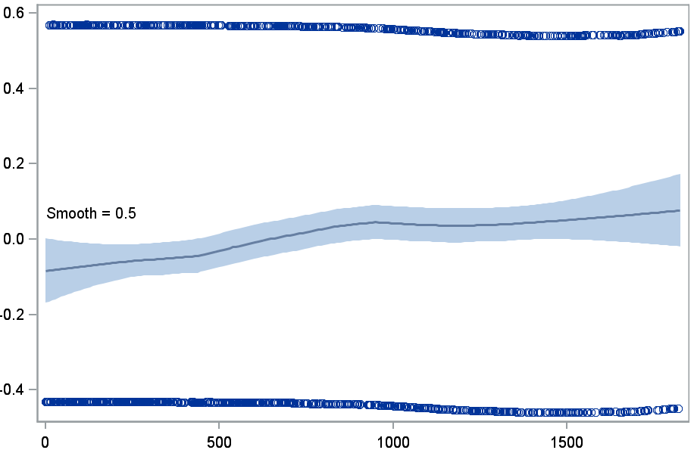
Schoenfeld residual
Days of follow-up

Supplementary Figure 2 Schoenfeld residuals for the primary outcome analysis using an as-treated exposure definition.

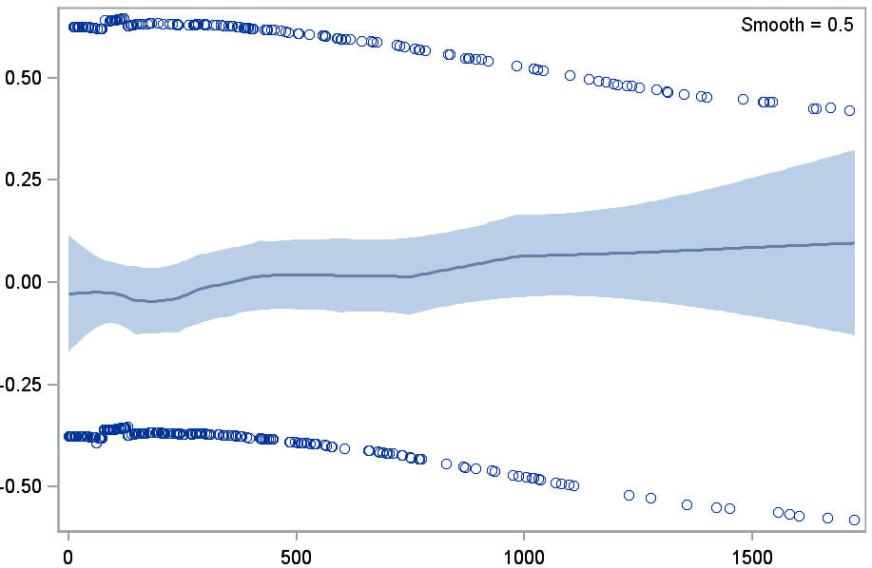
Days of follow-up
Schoenfeld residual

Supplementary Figure 3 Flow chart of patient inclusion in the study cohort (liraglutide users and DPP4 inhibitor users), Sweden, Denmark and Norway, January, 2010, through December, 2016

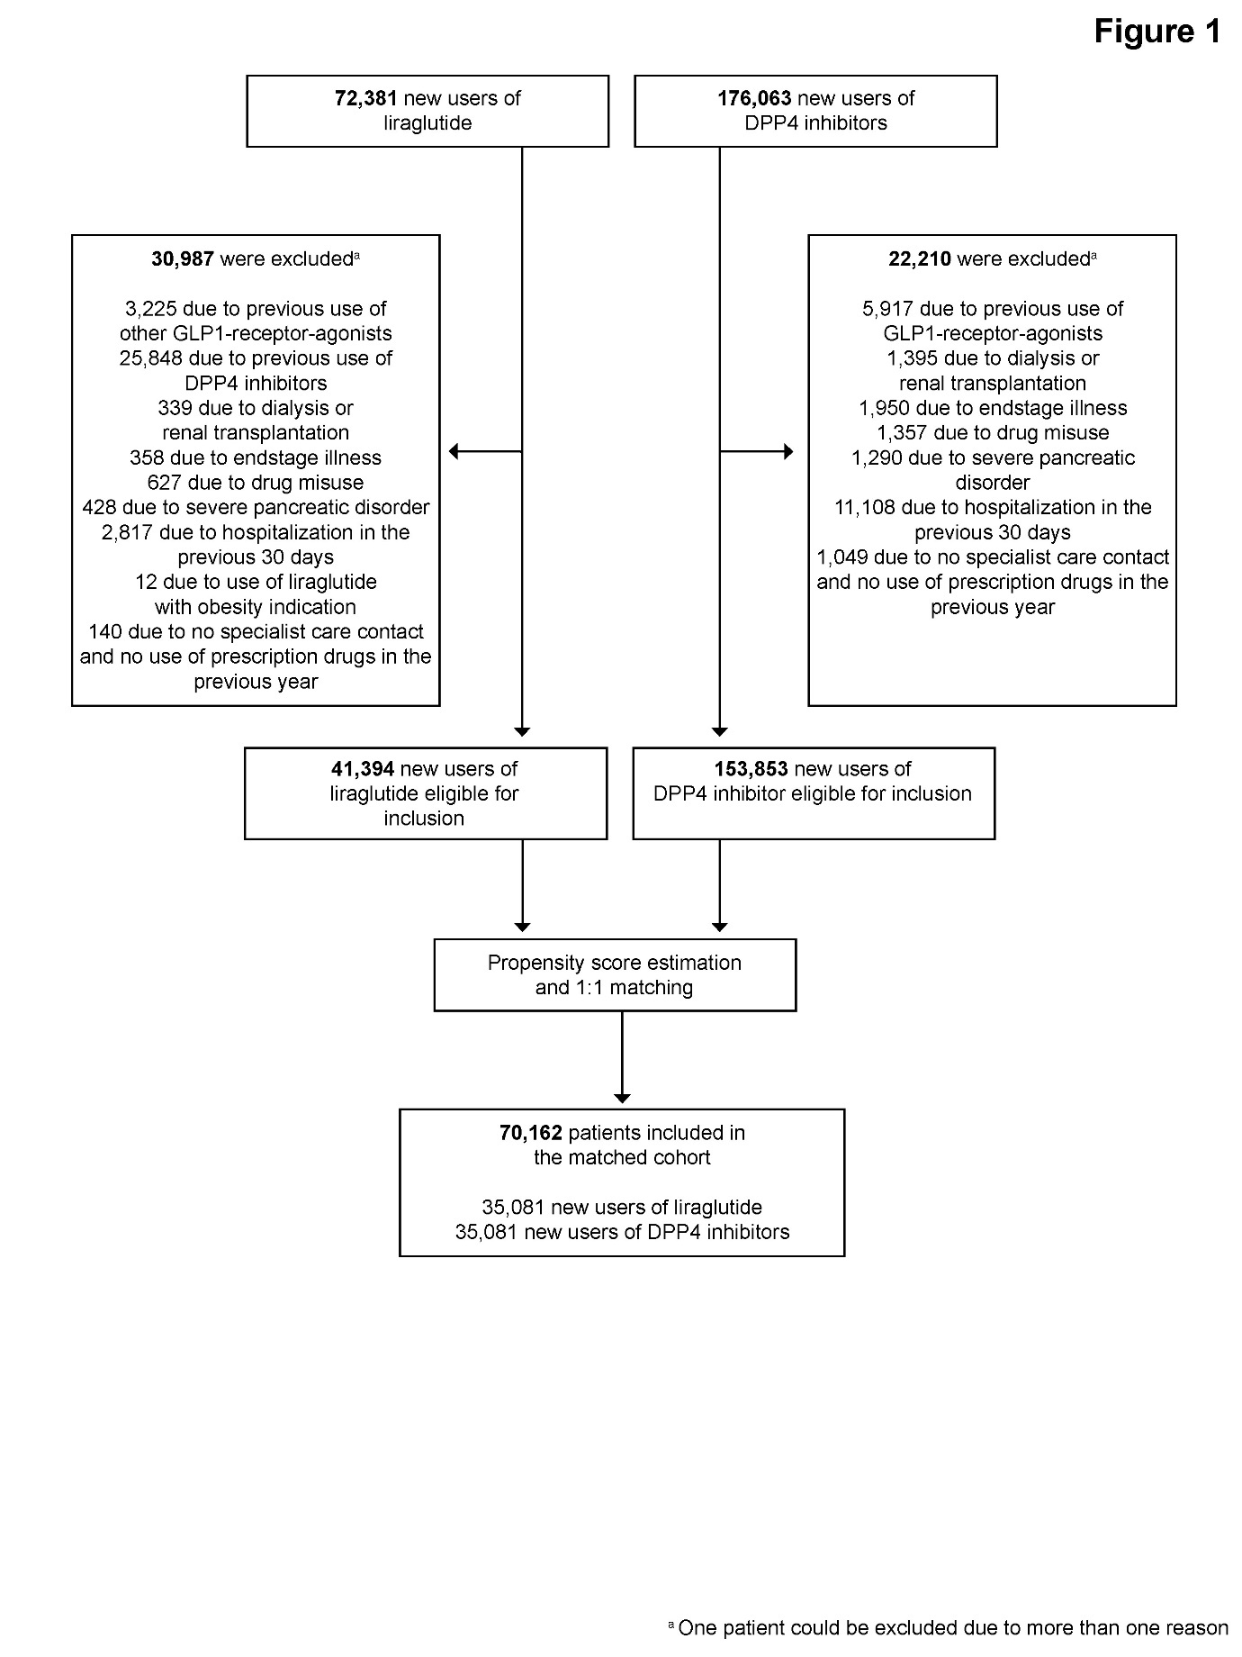
References
1. Wettermark B, Hammar N, Fored M, et al. The new Swedish Prescribed Drug Register—Opportunities for pharmacoepidemiological research and experience from the first six months. Pharmacoepidemiol Drug Saf 2007;16(7):726–35.
2. Pottegård A, Schmidt SAJ, Wallach-Kildemoes H, Sørensen HT, Hallas J, Schmidt M. Data Resource Profile: The Danish National Prescription Registry. Int J Epidemiol 2016;46(3):dyw213.
3. Norwegian Institute of Public Health. Norwegian Prescription Database [Internet]. [cited 2018 Jan 16];Available from: https://www.fhi.no/en/hn/health-registries/norpd/norwegian-prescription-database/
4. Furu K, Wettermark B, Andersen M, Martikainen JE, Almarsdottir AB, SÃ¸rensen HT. The Nordic Countries as a Cohort for Pharmacoepidemiological Research. Basic Clin Pharmacol Toxicol 2010;106(2):86–94.
5. Ludvigsson JF, Andersson E, Ekbom A, et al. External review and validation of the Swedish national inpatient register. BMC Public Health 2011;11(1):450.
6. Schmidt M, Schmidt SAJ, Sandegaard JL, Ehrenstein V, Pedersen L, Sørensen HT. The Danish National Patient Registry: a review of content, data quality, and research potential. Clin Epidemiol 2015;7:449.
7. Norwegian Institute of Public Health. Overview of the national health registries [Internet]. 2016 [cited 2019 Feb 19];Available from: https://www.fhi.no/en/more/access-to-data/about-the-national-health-registries2/
8. Norwegian Institute of Public Health. Norwegian Cause of Death Registry [Internet]. [cited 2019 Feb 19];Available from: https://www.fhi.no/en/hn/health-registries/cause-of-death-registry/
9. Brooke HL, Talbäck M, Hörnblad J, et al. The Swedish cause of death register. Eur J Epidemiol 2017;32(9):765–73.
10. Helweg-Larsen K. The Danish Register of Causes of Death. Scand J Public Health 2011;39(7_suppl):26–9.
11. Ludvigsson JF, Almqvist C, Bonamy A-KE, et al. Registers of the Swedish total population and their use in medical research. Eur J Epidemiol 2016;31(2):125–36.
12. Schmidt M, Pedersen L, Sørensen HT. The Danish Civil Registration System as a tool in epidemiology. Eur J Epidemiol 2014;29(8):541–9.
13. National Registry. The Norwegian Tax Administration. [Internet]. Available from: https://www.skatteetaten.no/en/person/national-registry/
14. Gudbjörnsdottir S, Svensson A-M, Eliasson B, et al. National Diabetes Register. Annual Report 2016. 2017.

