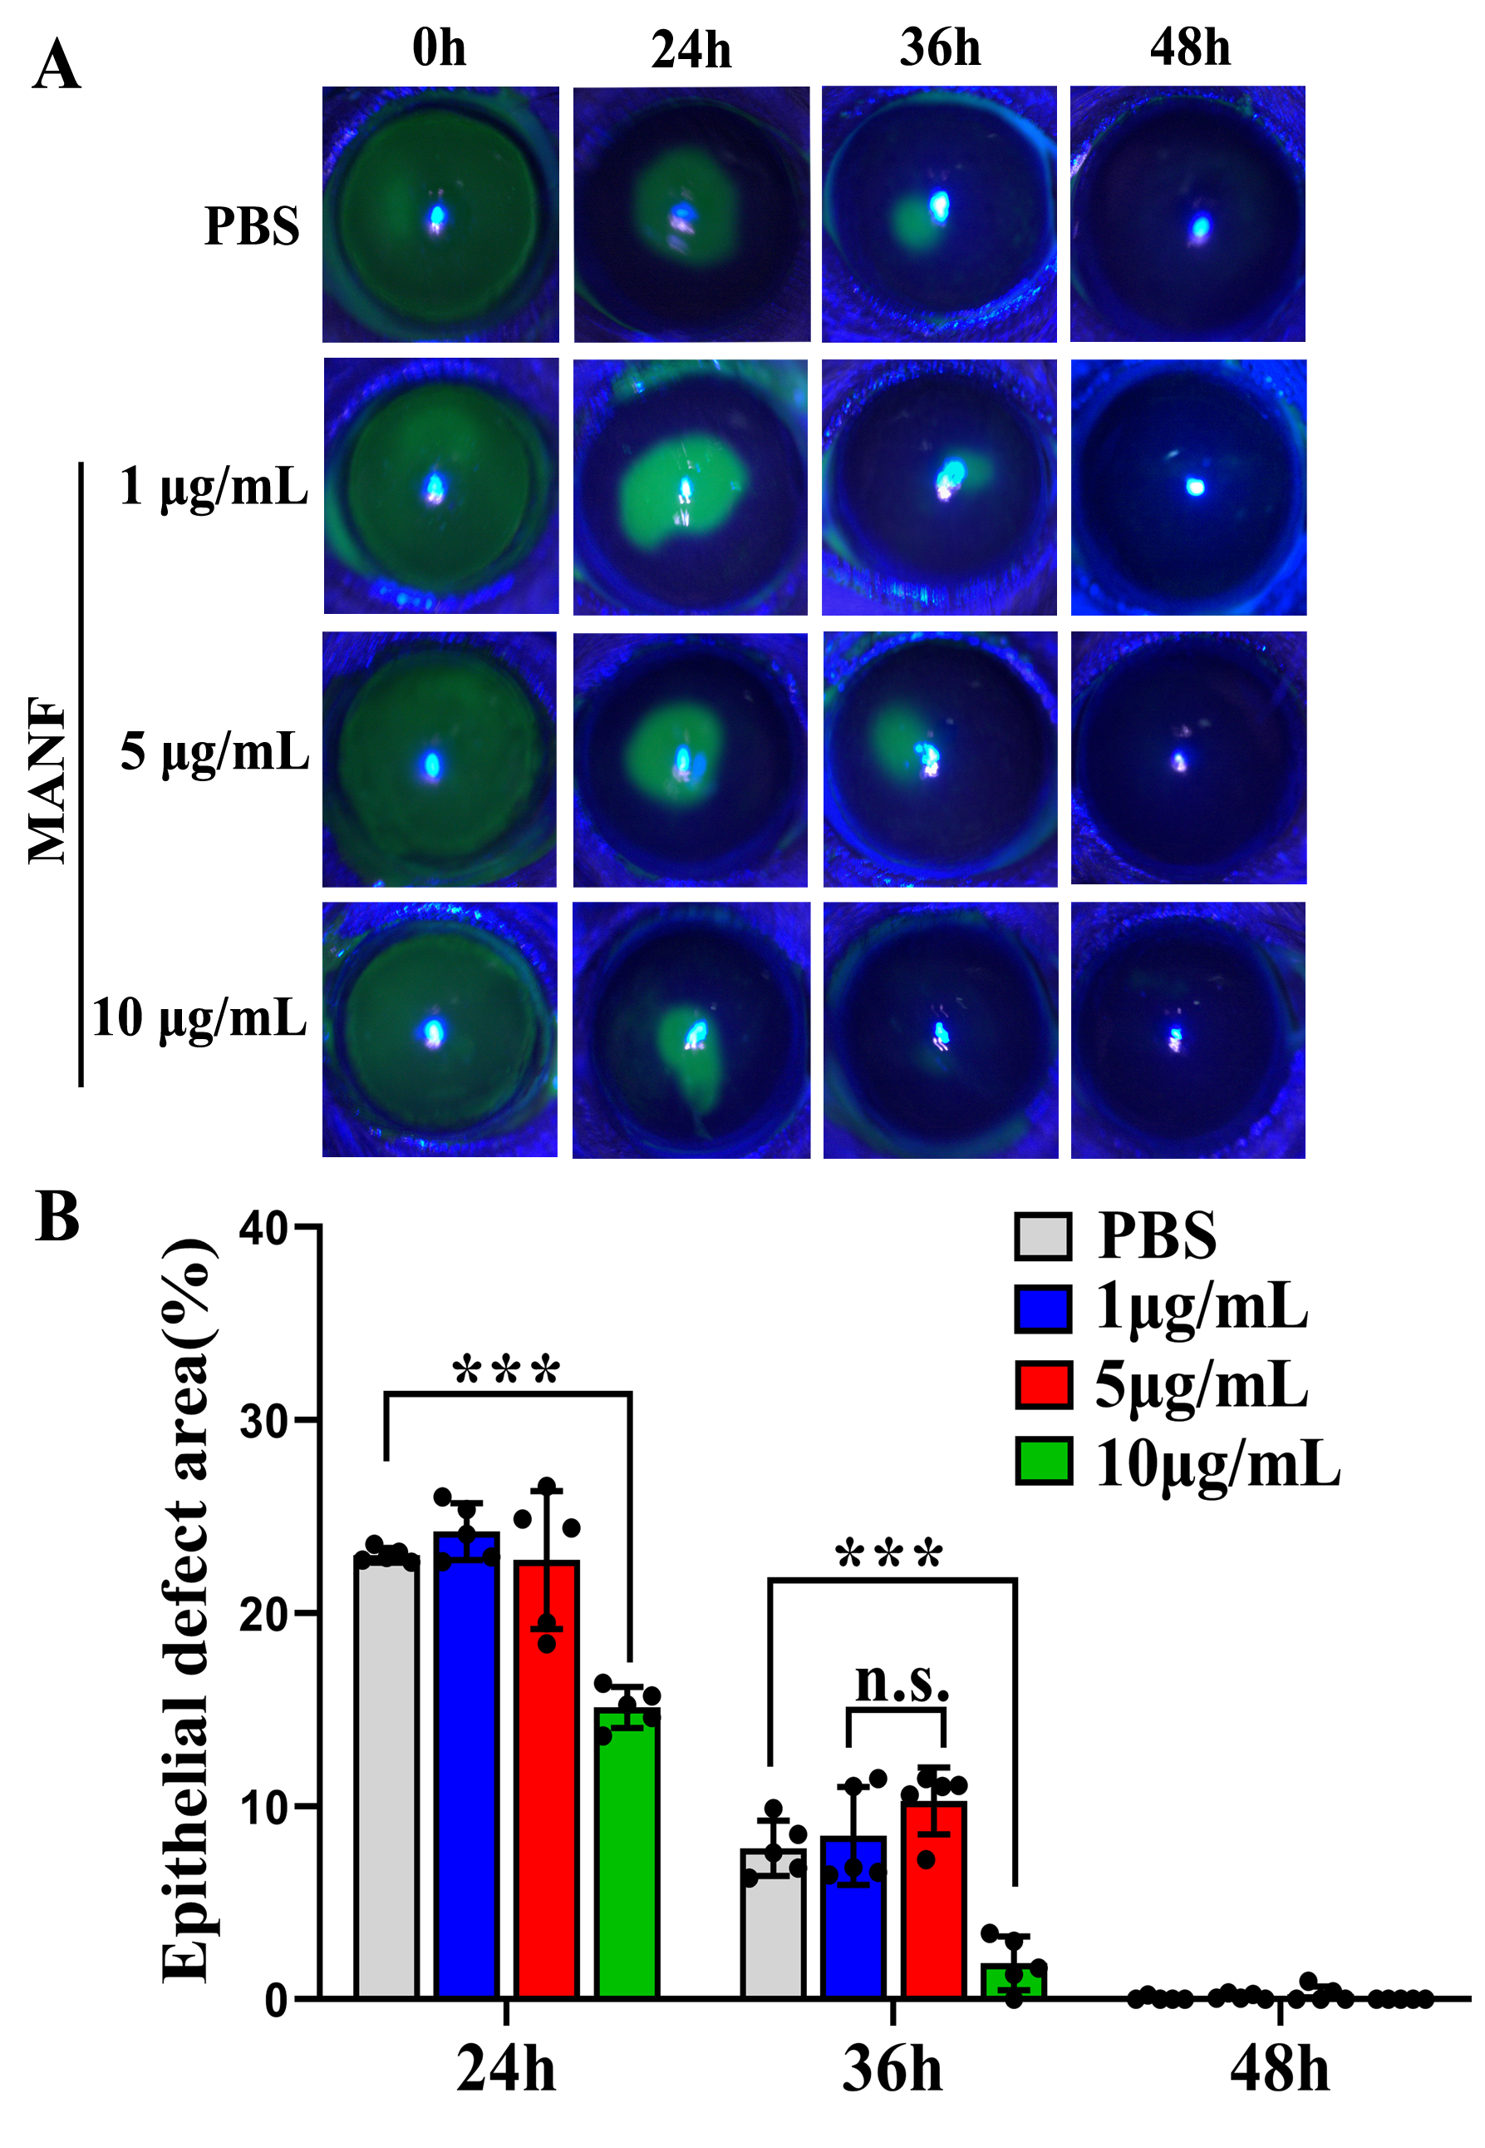
Supplemental Figure 1. Exogenous MANF promoted normal corneal epithelial wound healing at a suitable concentration
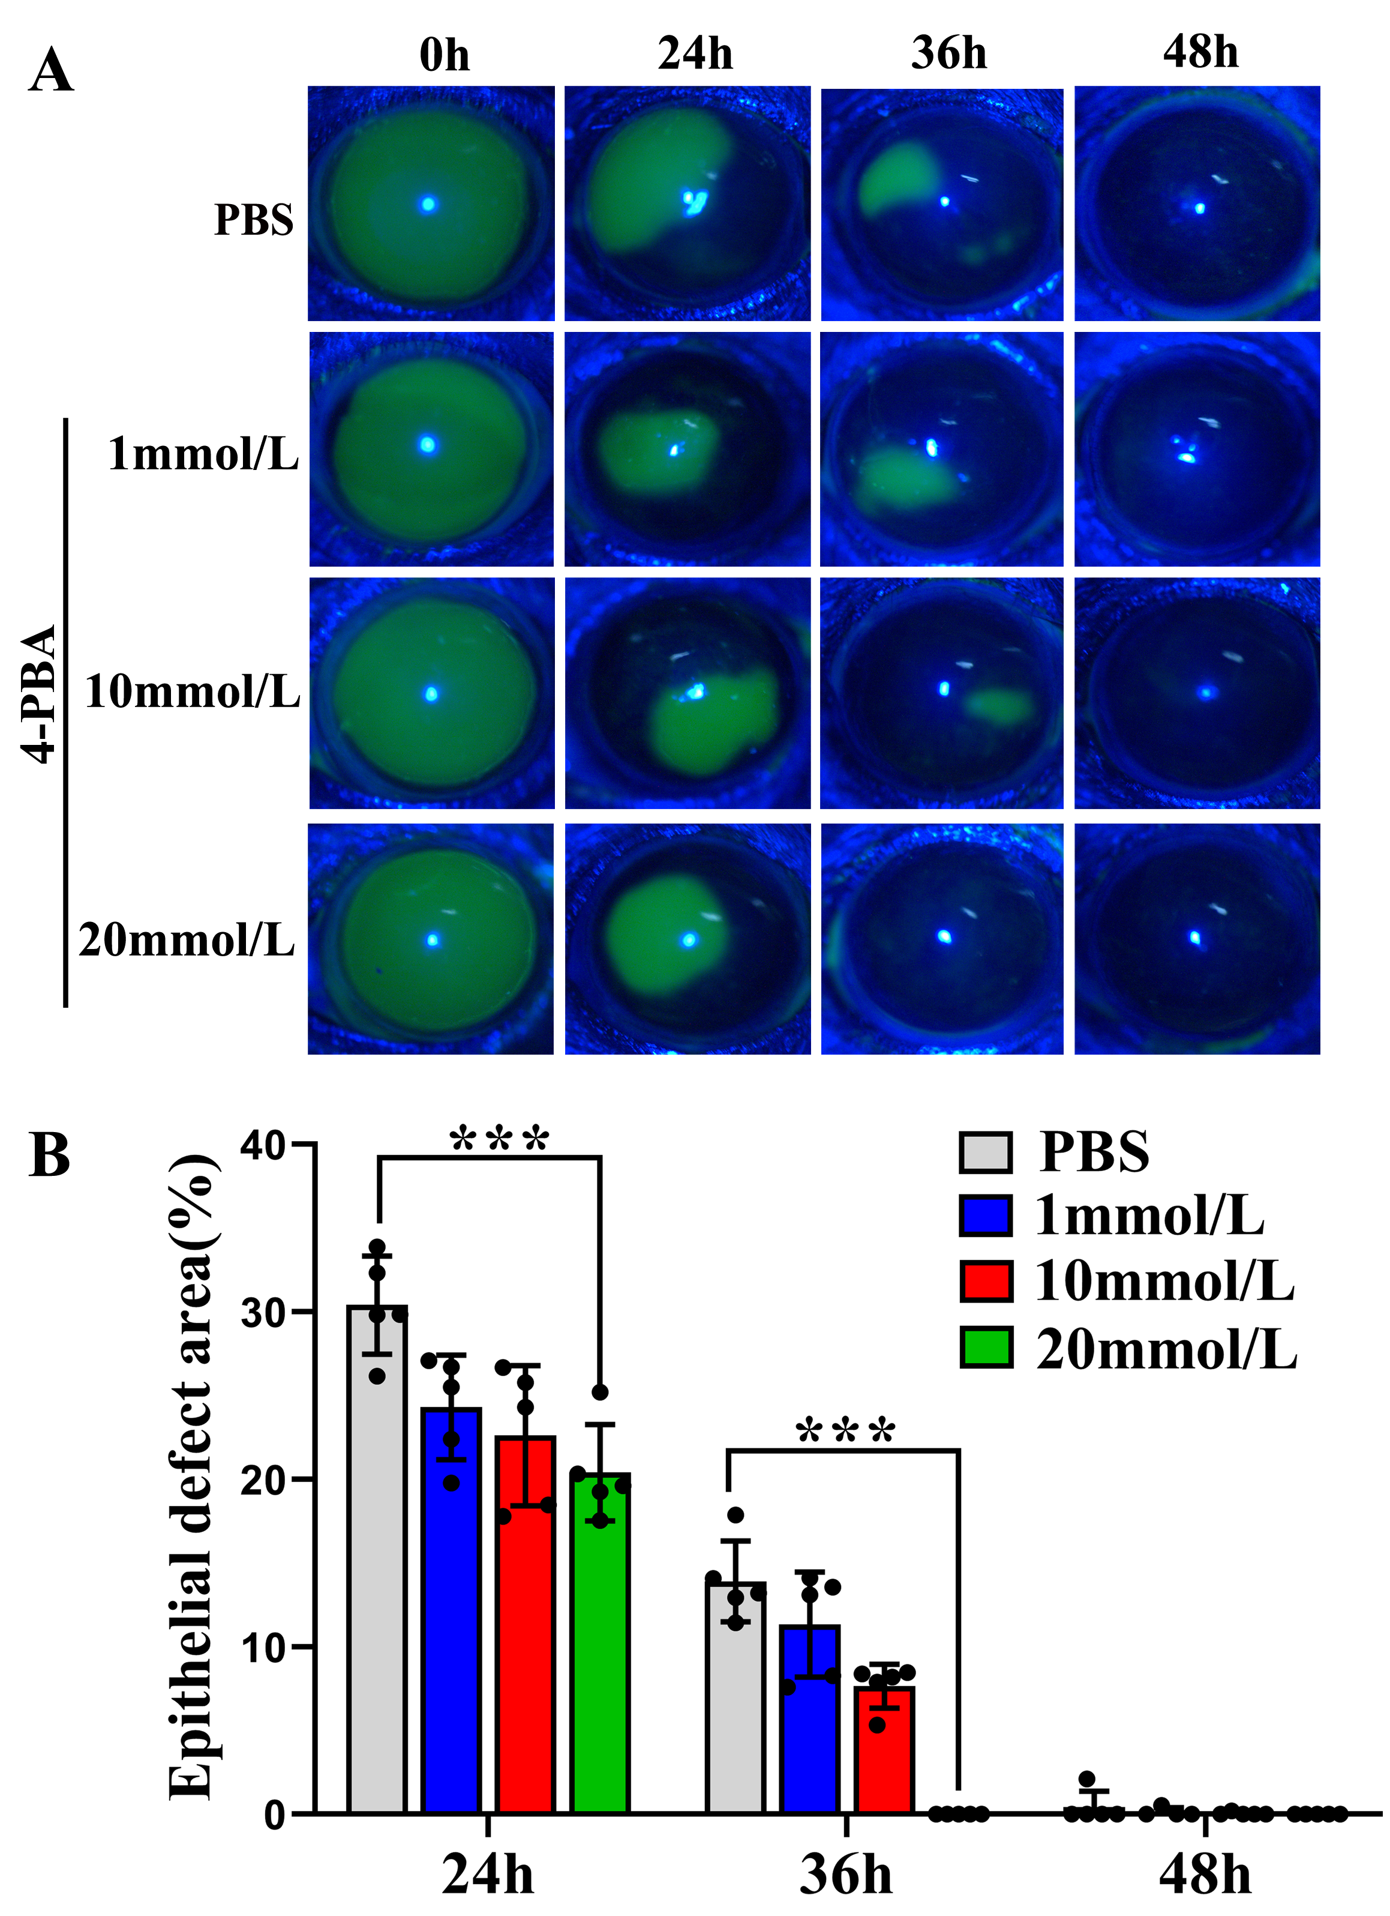
Supplemental Figure 2. Inhibitor of ER stress (4-PBA) promoted normal corneal epithelial wound healing at a suitable concentration

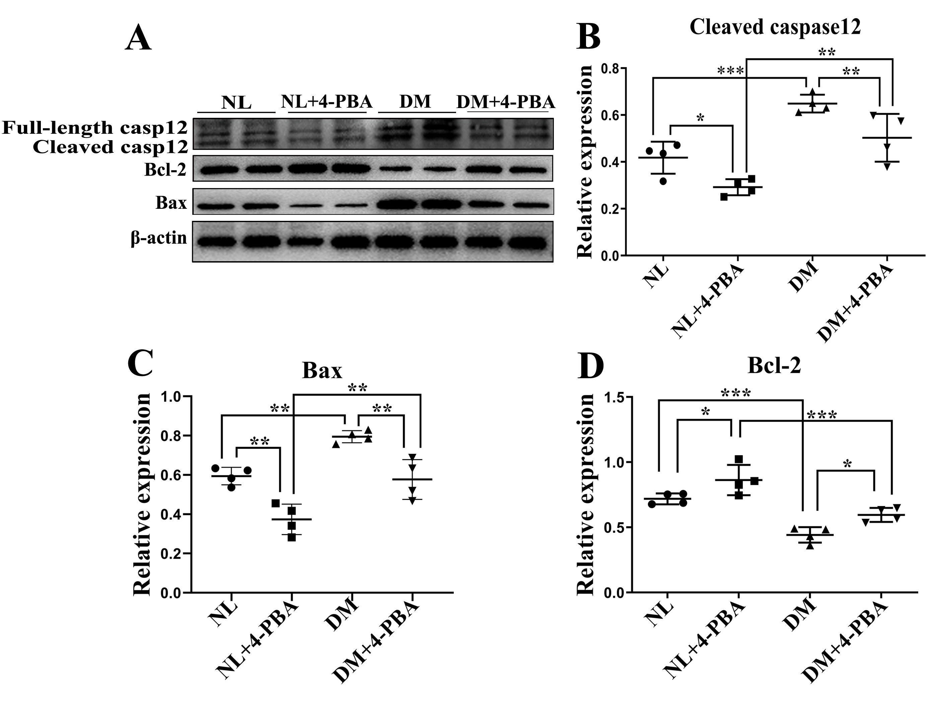
Supplemental Figure 3. ER-stress inhibitor inhibited ER stress-mediated apoptosis
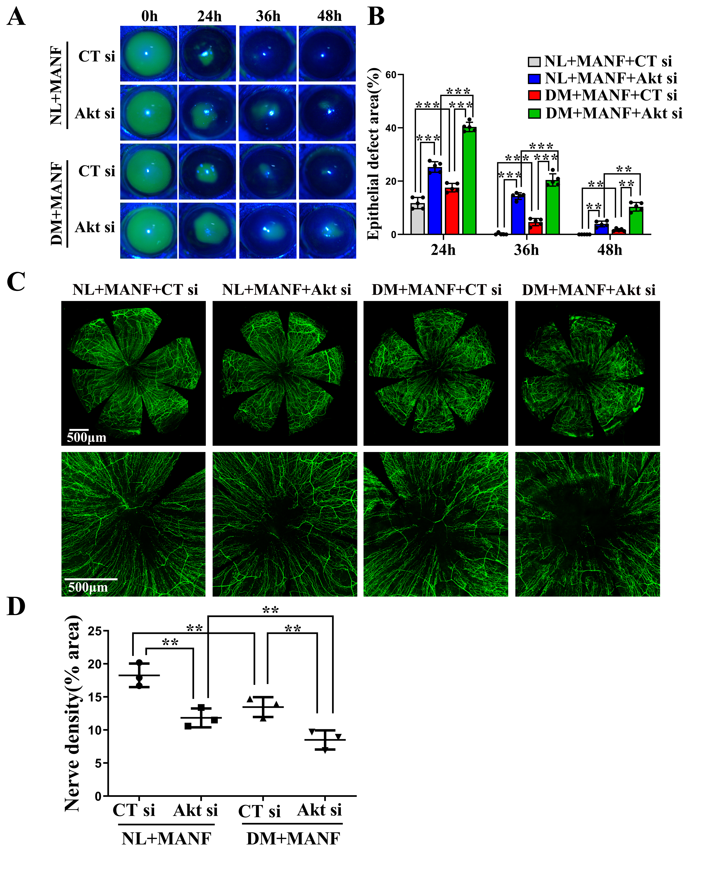

Supplemental Figure 4. Akt-specific siRNA delayed corneal epithelial wound healing and nerve regeneration relieved by MANF
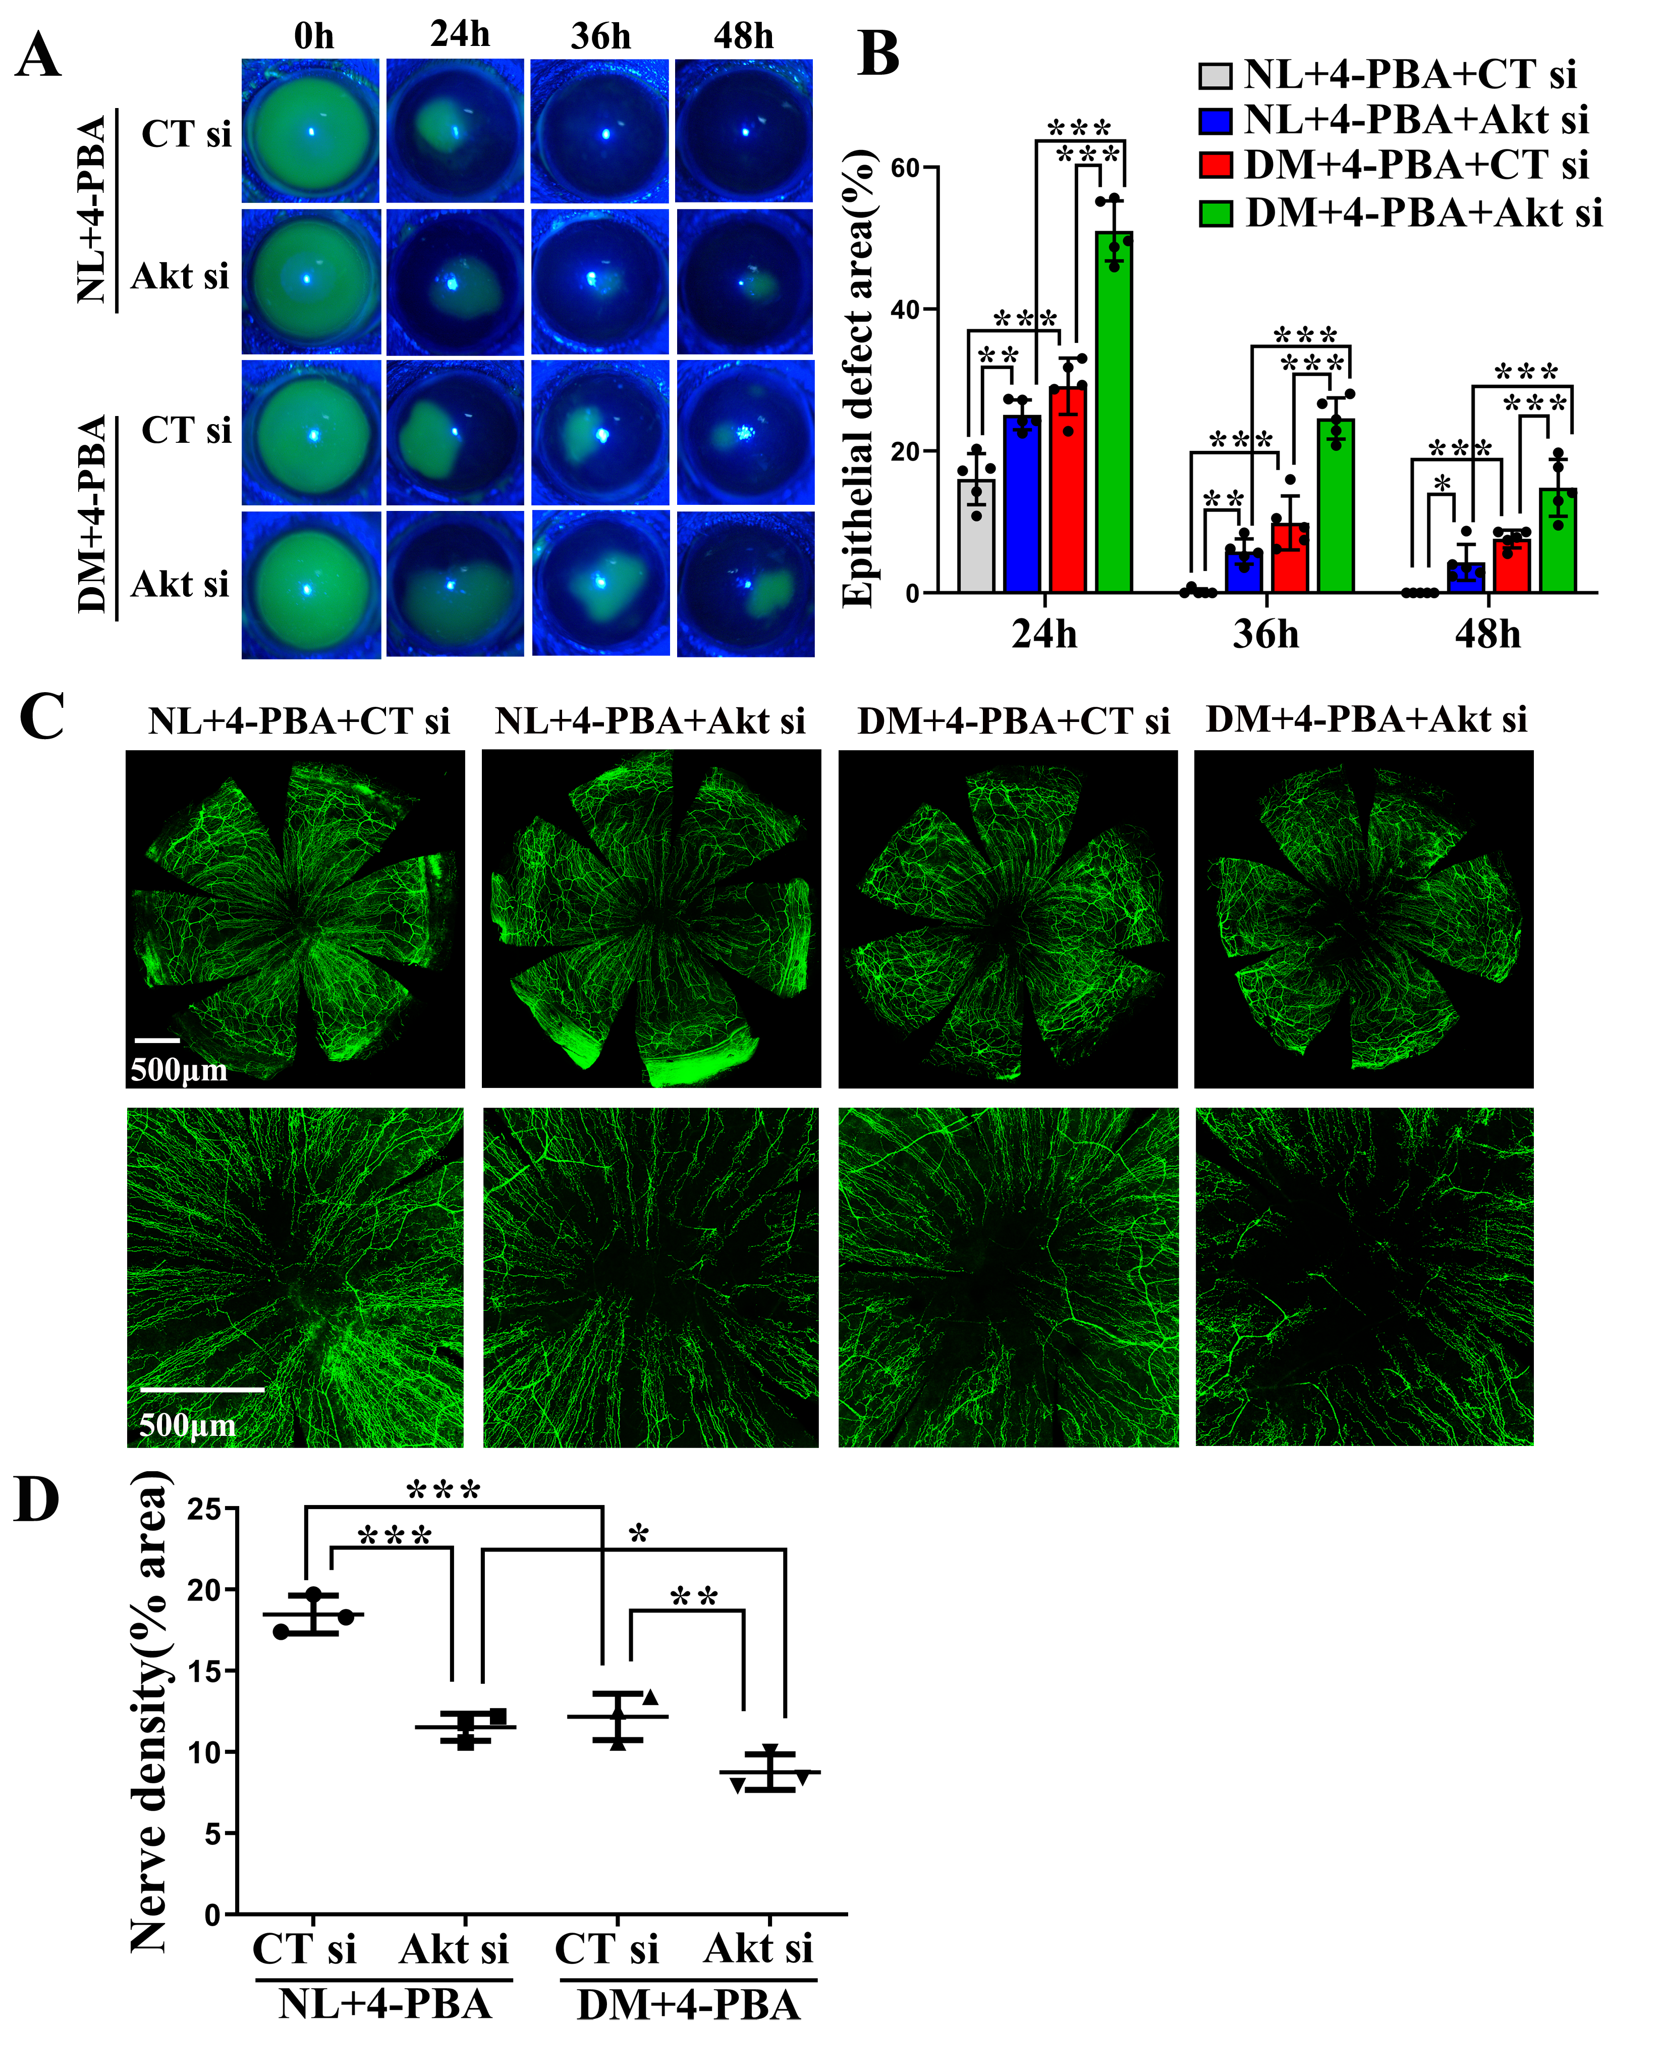
Supplemental Figure 5. Akt-specific siRNA delayed corneal epithelial wound healing and nerve regeneration relieved by 4-PBA

Figure Legends
Supplemental Figure 1. Exogenous MANF promoted normal corneal epithelial wound healing at a suitable concentration. In order to find out the optimum concentration, normal mice were injected subconjunctivally with PBS as a control or with rhMANF protein (1, 5 and 10 μg/mL) 24h before epithelium debridement and at 0 and 24h post-wounding. At 0h, the corneas were wounded by epithelium debridement (2.5-mm diameter). The wound healing progress was monitored by fluorescence staining for epithelial defects and photographed with a slit-lamp microscope at 0, 24, 36, and 48h post-wounding. (A) Epithelial-defect areas were observed by fluorescence staining. (B) The wound sizes were calculated by Image J software (n = 5). ***p < 0.001, n.s. -not significant (one-way ANOVA).

Supplemental Figure 2. Inhibitor of ER stress (4-PBA) promoted normal corneal epithelial wound healing at a suitable concentration. In order to find out the optimum concentration, normal mice were injected subconjunctivally with PBS as a control or with 4-PBA (1, 10 and 20 mmol/L) 24h before epithelium wounding and at 0 and 24h post-wounding. At 0h, the corneas were wounded by epithelium debridement (2.5-mm diameter). The wound healing progress was monitored by fluorescence staining for epithelial defects and photographed with a slit-lamp microscope at 0, 24, 36, and 48h post-wounding. (A) Epithelial-defect areas were observed by fluorescence staining. (B) The wound sizes were calculated by Image J software (n = 5). ***p < 0.001 (one-way ANOVA).

Supplemental Figure 3. ER-stress inhibitor inhibited ER stress-mediated apoptosis. Normal and diabetic mice were treated with PBS (as the control) or 4-PBA. At 48h post-wounding, corneal epithelial cells were collected for western blot analysis. DM, wounded mice with diabetes mellitus; DM+4-PBA, wounded mice with diabetes mellitus treated with 4-PBA; NL, wounded normoglycemic mice treated with PBS; NL+4-PBA, wounded normoglycemic mice treated with 4-PBA. Two samples/lanes represent each condition, three corneas as one sample. (A) Western blotting bands for caspase 12, Bax, and Bcl-2, with or without 4-PBA treatment. (B) Quantified intensities of western blotting bands for cleaved caspase 12 compared to β-actin (n = 4 samples). (C) Quantified intensities of western blotting bands for Bax compared to β-actin (n = 4 samples). (D) Quantified intensities of western blotting bands for Bcl-2 compared to β-actin (n = 4 samples). *p < 0.05, **p < 0.01, ***p < 0.001 (one-way ANOVA).

Supplemental Figure 4. Akt-specific siRNA delayed corneal epithelial wound healing and nerve regeneration relieved by MANF. Normal and diabetic corneas were pretreated with non-specific control siRNA (CT si) or Akt-specific siRNA (Akt si) 24 and 4h prior to epithelium debridement. At 0h, the corneas were wounded by epithelium debridement (2.5-mm diameter) and allowed to heal for 48h. Recombinant human MANF was injected as described in Figure 6. An additional subconjunctival injection of CT si or Akt si was performed at 24h post-wounding. (A) Epithelial defect areas were observed by fluorescence staining. (B) Wound sizes were calculated using Image J software (n = 5). **p < 0.01 and ***p < 0.001 (one-way ANOVA). (C) Whole-mount confocal microscopy of the corneas pretreated with CT si, or Akt si and processed at 48 h post-wounding. Top panels: whole corneal images of nerve fibres; bottom panels: high-magnification images showing nerve fibres of corneal centres; scale bar: 500 µm. (D) Nerve densities of entire corneas (top panels) were calculated based on the areas positive for β-III tubulin expression, using Image J software, and presented as % areas (n = 3). **p < 0.01 (one-way ANOVA).

Supplemental Figure 5. Akt-specific siRNA delayed corneal epithelial wound healing and nerve regeneration relieved by 4-PBA. Normal and diabetic corneas were pretreated with non-specific control siRNA (CT si) or Akt-specific siRNA (Akt si) 24 and 4h prior to epithelium debridement. At 0h, the corneas were wounded by epithelium debridement (2.5-mm diameter) and allowed to heal for 48h. ER stress inhibitor 4-PBA was injected as described in Figure 7. An additional subconjunctival injection of CT si or Akt si was performed at 24h post-wounding. (A) Epithelial defect areas were observed by fluorescence staining. (B) Wound sizes were calculated using Adobe Photoshop software (n = 5). **p < 0.01 and ***p < 0.001 (one-way ANOVA). (C) Whole-mount confocal microscopy of the corneas pretreated with CT si, or Akt si and processed at 48h post-wounding. Top panels: whole corneal images of nerve fibres; bottom panels: high-magnification images showing nerve fibres of corneal centres; scale bar: 500 µm. (D) Nerve densities of entire corneas (top panels) were calculated based on the areas positive for β-III tubulin expression, using Image J software, and presented as % areas (n = 3). *p < 0.05, **p < 0.01, ***p < 0.001 (one-way ANOVA).

