

**Supplementary Figure 1** Stimulation index calculated for evaluating glucose-stimulated insulin secretion using the dynamic glucose perifusion data.

Islets from non-diabetic (ND) and type 2 diabetic (T2D) donors with normal body weight (ND, n=38 donors; T2D, n=14 donors) and with obesity (ND, n=11 donors; T2D, n=12 donors) were subjected to dynamic perifusion at low (1.67 mM) and high glucose (20 mM) solutions. Stimulation index was calculated by dividing the average insulin concentration of the high-glucose phase by that of the low-glucose phase. The box extends from the 25th to 75th percentiles. The line in the middle of the box is plotted at the median. The whiskers go down to the smallest value and up to the largest.

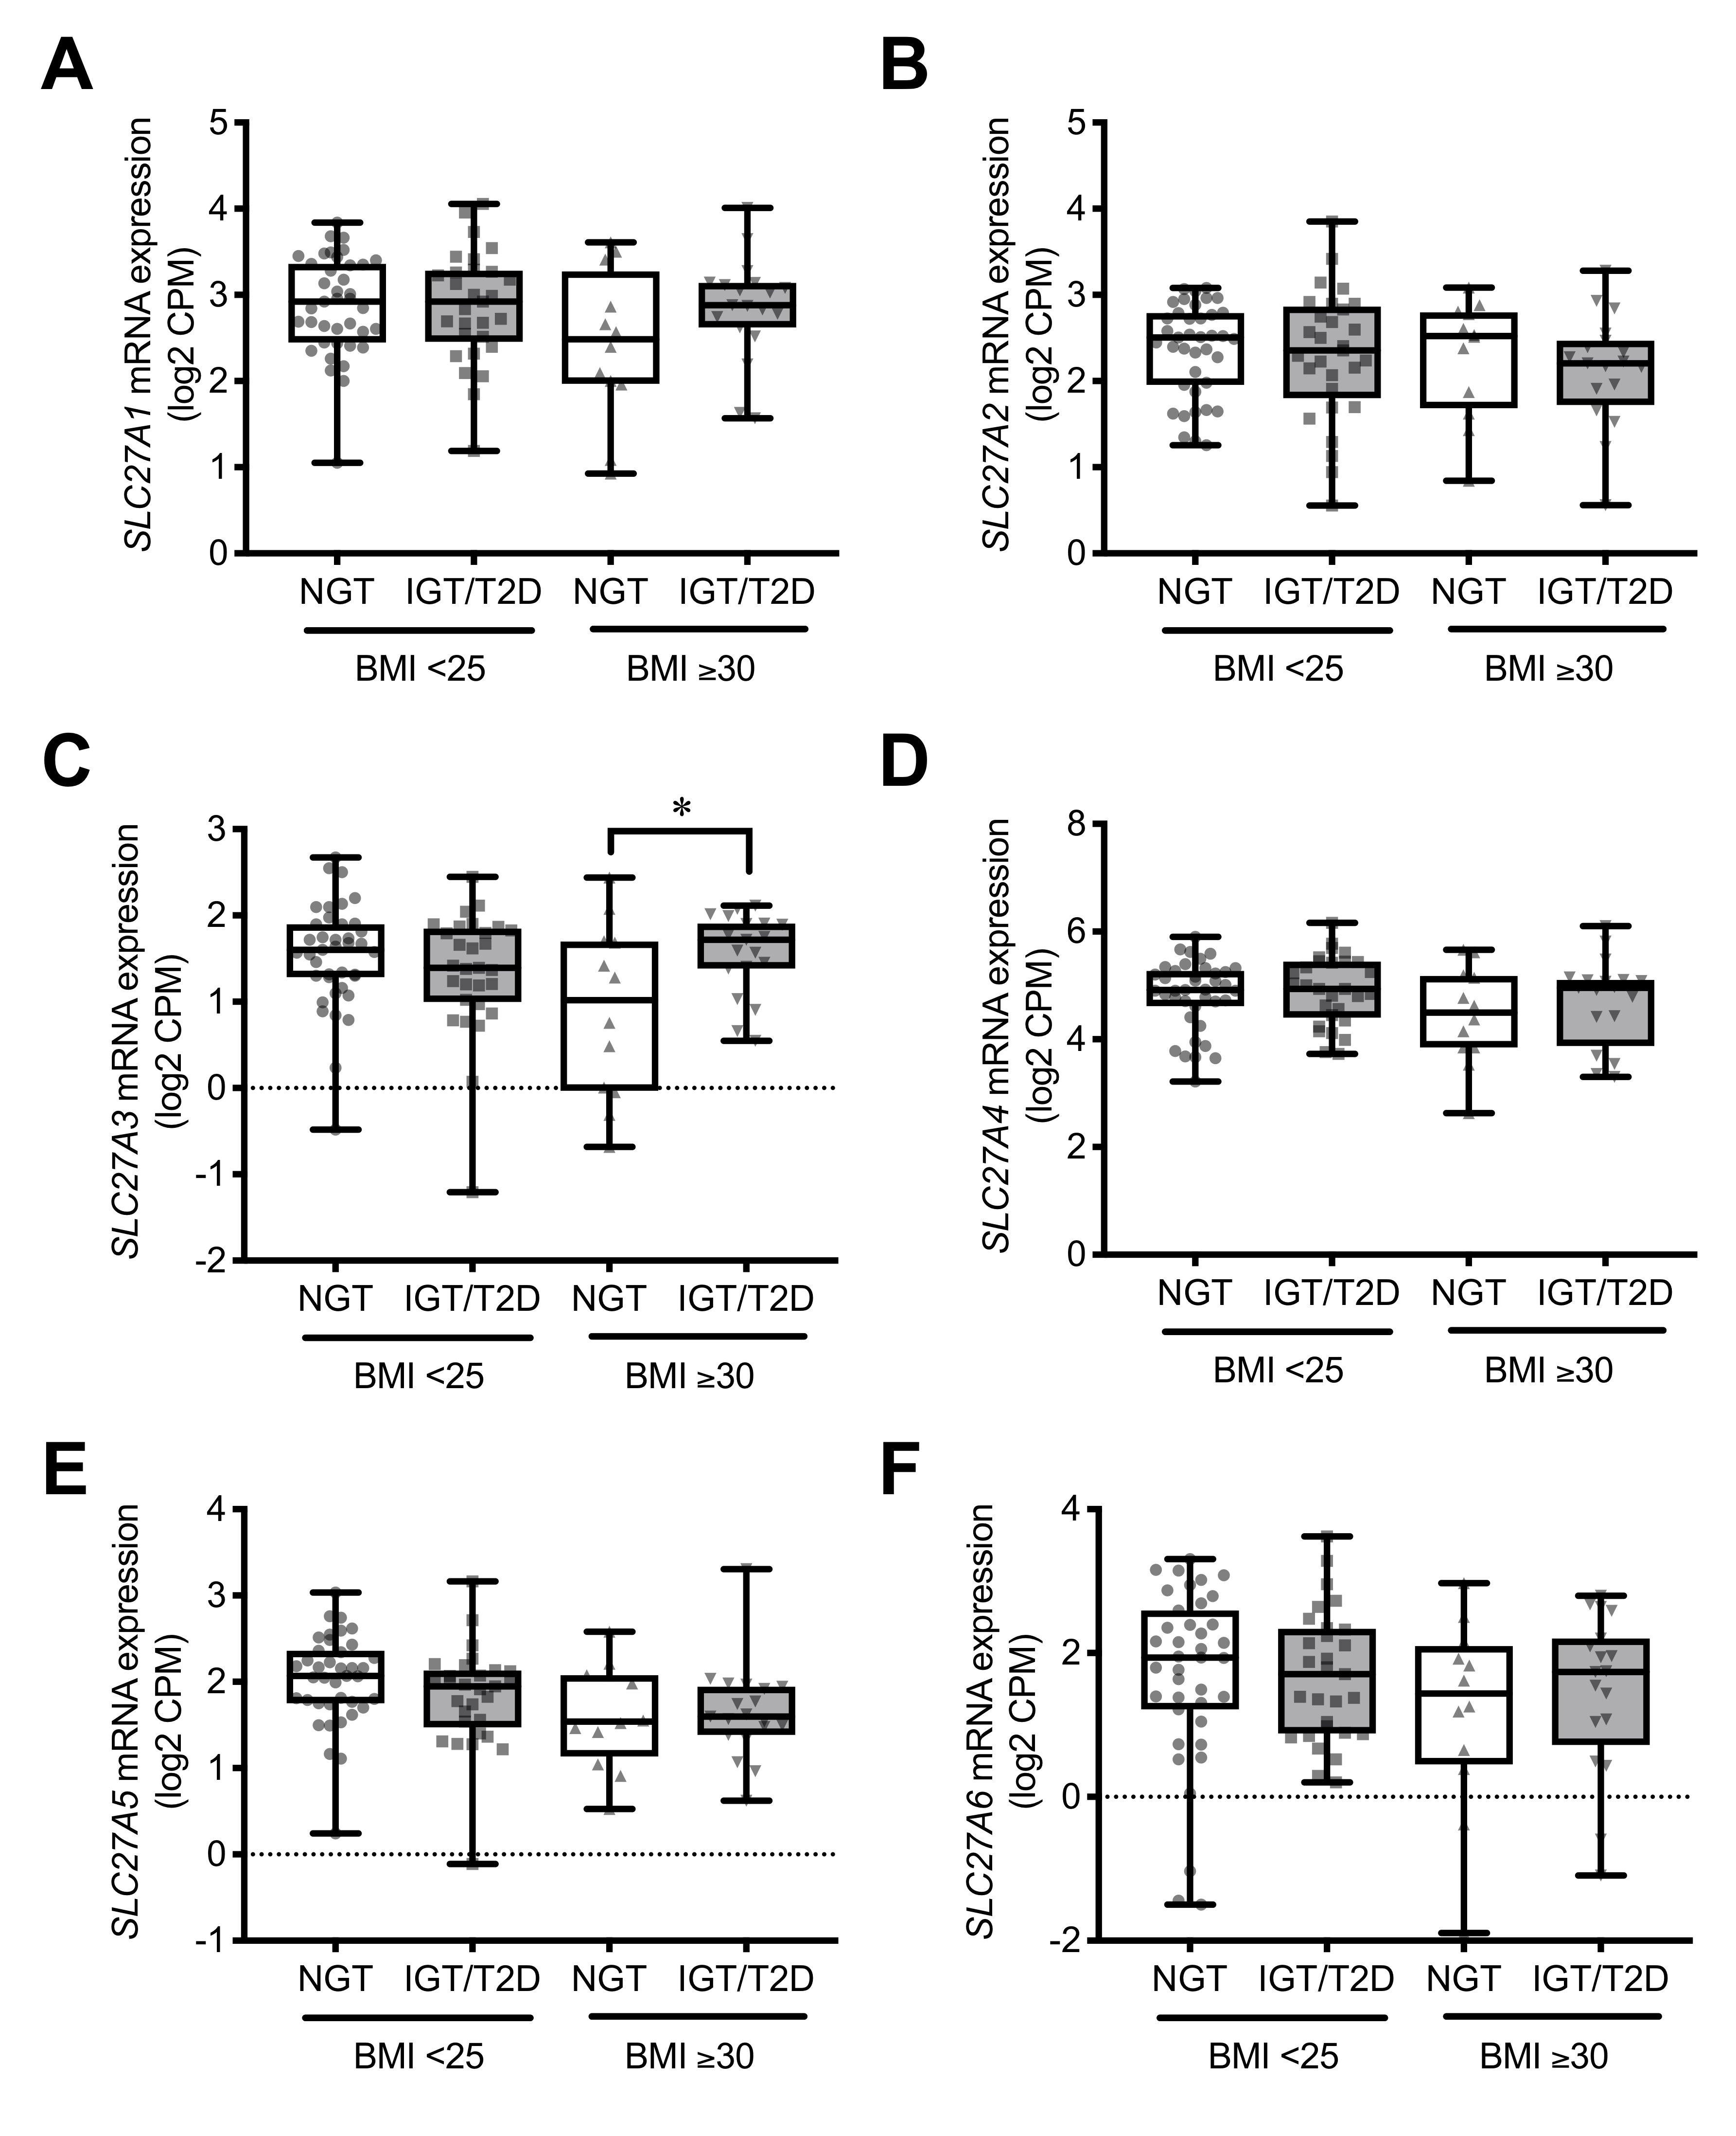

**Supplementary Figure 2** Expression of SLC27 family (SLC27A1-6) in human pancreatic islets.

*A-F*: *SLC27A1-6* mRNA levels in islets from non-diabetic (ND, HbA1c <6.0%, 42 mmol/mol) and impaired glucose tolerant or type 2 diabetic (IGT/T2D, HbA1c ≥6.0%, 42 mmol/mol) donors with normal body weight (BMI <25 kg/m2; ND, *n*=39; IGT/T2D, *n*=29) and with obesity (BMI ≥30 kg/m2; ND, *n*=12; IGT/T2D, *n*=19). The P values were determined by Student’s two-tailed t-test (unpaired). The box extends from the 25th to 75th percentiles. The line in the middle of the box is plotted at the median. The whiskers go down to the smallest value and up to the largest.

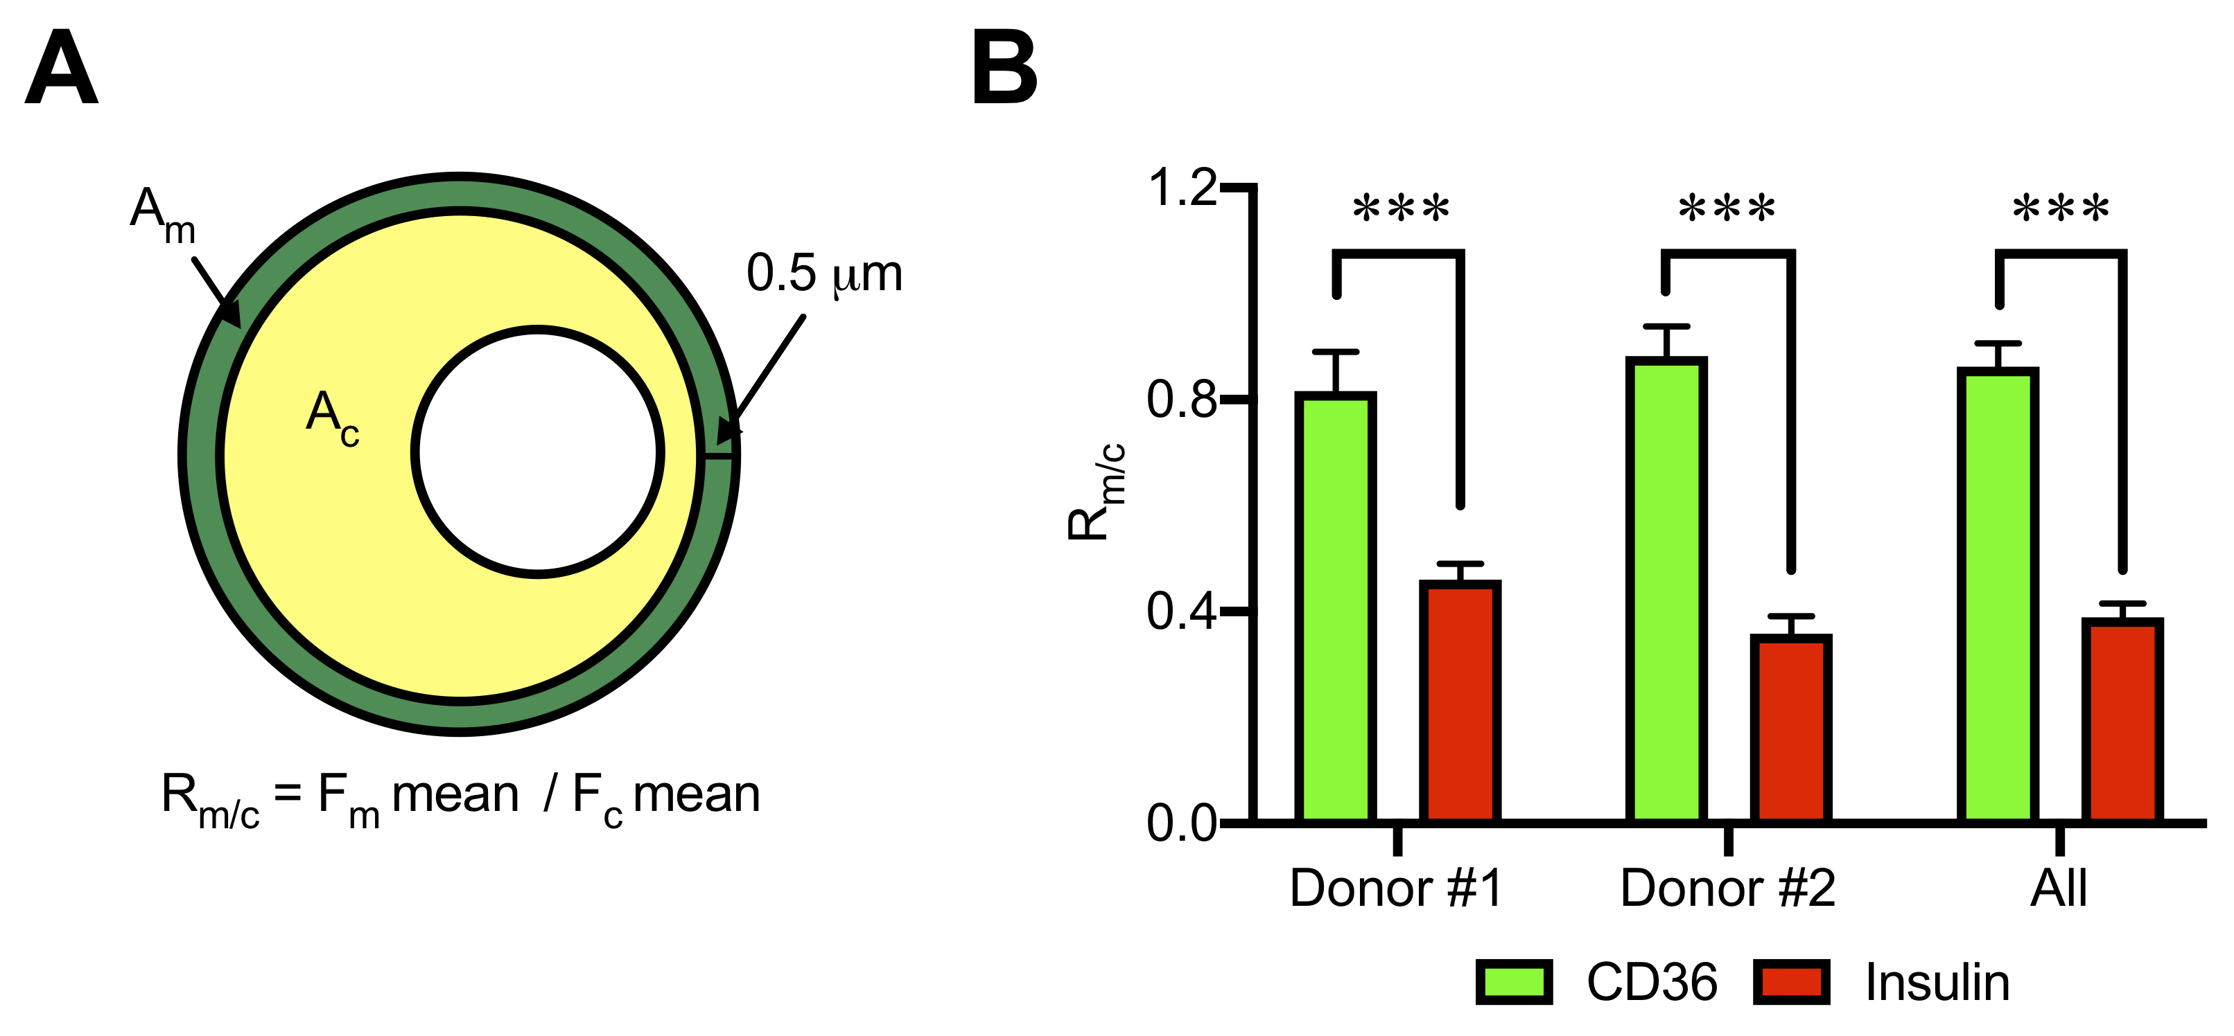

**Supplementary Figure 3** Localization of CD36 and insulin in human β-cells.

*A*: A model explaining the method for the fluorescent localization analysis on confocal micrographs of insulin-positive human islet cells. Localization of CD36 and insulin was calculated from the fluorescent intensity sums (F) in the area within 0.5 μm from the cellular edge (Am; corresponding to the plasma membrane) and intracellular area excluding the area occupied by the nucleus and Am (Ac; corresponding to the cytosol). The F in each area was normalized to each area size (F mean). The ratio of F means between Am and Ac (Rm/c) was calculated for each cell. *B*: Results of the fluorescent localization analysis (Rm/c) for CD36 and insulin. N=8 and n=18 cells for donor #1 and #2 (same donors as in Fig. 2D), respectively and n=26 cells in total were analyzed. \*\*\**P*<0.001. The *P* values were determined by Student’s two-tailed t-test (unpaired).

**Supplementary Figure 4** Additional characterizations of CD36 overexpressing INS-1 cells.

*A*: Doxycycline-induced CD36 overexpression. CD36 protein levels after 72 h incubation of INS-1 cells carrying a Tet-on system for CD36 overexpression with the increasing amount of doxycycline. The Western blot bands of β-actin (βACT) are shown as a loading control.*B*: Intracellular insulin content normalized to the protein content. N=5 for each group.*C*: Phosphorylation levels of AKT Ser473. Phosphorylated protein signals were normalized to the total protein levels. The total protein images obtained using the Stain-Free technology are shown as a loading control (Loading). N=4 for each group. DOX- and DOX+ represents INS-1 cells without and with doxycycline-induced CD36 overexpression, respectively. \*\**P*<0.01. The P values were determined by Student’s two-tailed t-test (unpaired).

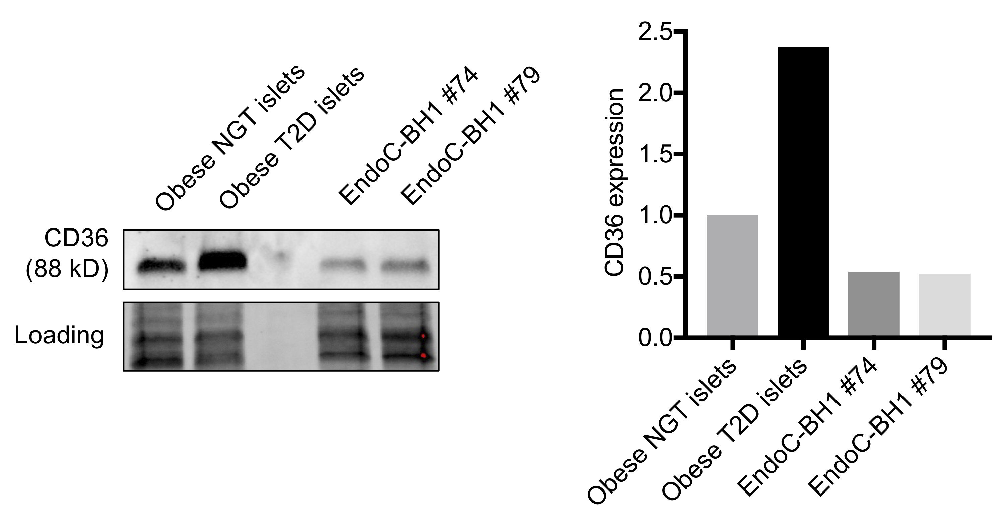

**Supplementary Figure 5** CD36 protein levels in human pancreatic islets and EndoC-βH1 cells.

Western blot analysis of CD36 in human islets from obese non-diabetic (ND, BMI 37 kg/m2, HbA1c 6.1%, 43 mmol/mol) and obese type 2 diabetic (T2D, BMI 33.3 kg/m2, HbA1c 7.3%, 56 mmol/mol) donors and EndoC-βH1 cells (passage No. #74 and #79). The total protein images obtained using the Stain-Free technology are shown as a loading control (Loading).

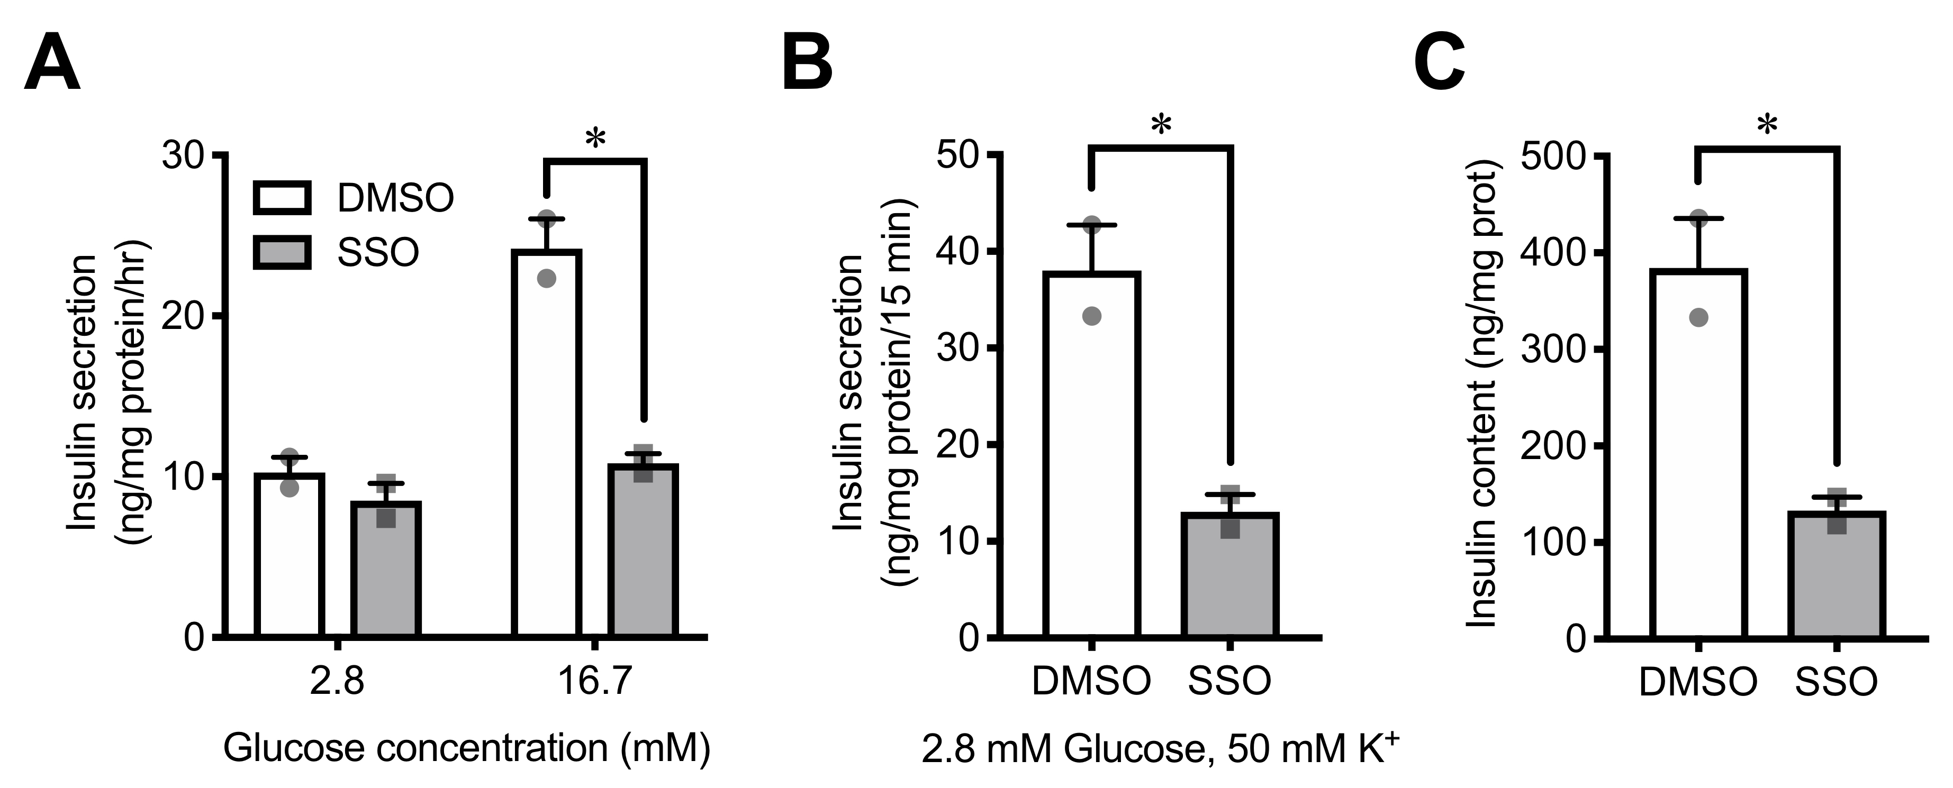

**Supplementary Figure 6** Effects of sulfo-*N*-succinimidyl oleate on INS-1 832/13 cell functions.

INS-1 832/13 cells were co-cultured with 0.1 mM sulfo-*N*-succinimidyl oleate (SSO) or DMSO (solvent control) for 72 h and then evaluated glucose- and depolarization-induced insulin secretion and insulin content. *A*and *B*: Insulin secretion at 2.8 mM or 16.7 mM glucose for 1 h (*A*) and at 2.8 mM glucose with 50 mM K+ for 15 min (*B*). *C*: Intracellular insulin content normalized to the protein content. N=2 for each group. \**P*<0.05. The *P* values were determined by Student’s two-tailed t-test (unpaired).

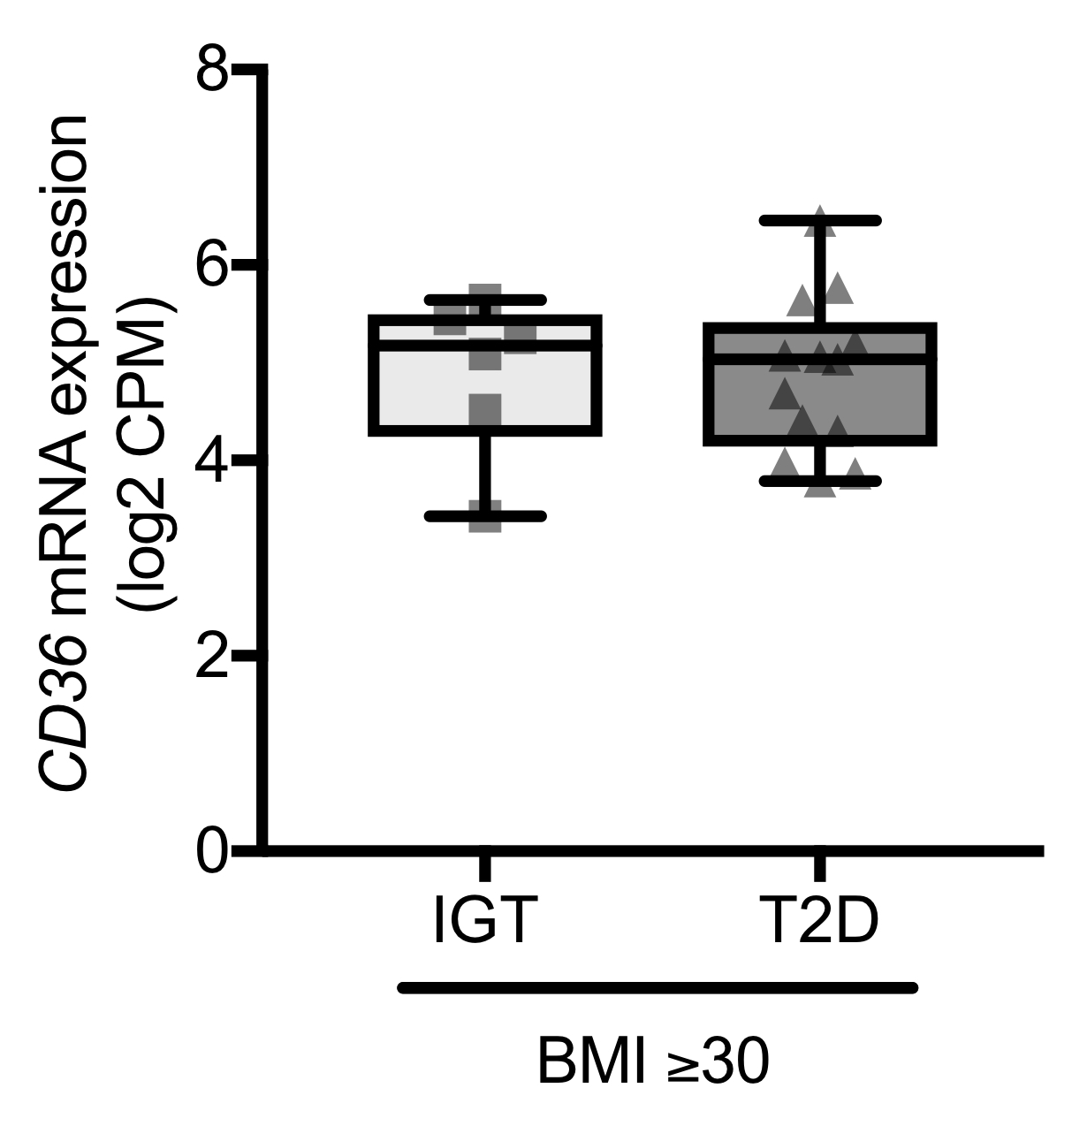

**Supplementary Figure 7** Expression of CD36 in human pancreatic islets of obese donors.

*CD36* mRNA levels in islets from impaired glucose tolerant (IGT) or type 2 diabetic (T2D) donors with obesity (BMI ≥30 kg/m2; IGT, *n*=6; T2D, *n*=13). The box extends from the 25th to 75th percentiles. The line in the middle of the box is plotted at the median. The whiskers go down to the smallest value and up to the largest.

**Supplementary Table 1** Donor characteristics for experiments with human pancreatic islets.

|  |  |  |  |  |  |
| --- | --- | --- | --- | --- | --- |
| Group | n | Gender  (Male / Female) | Age  (years old) | BMI  (kg/m2) | HbA1c  (%, mmol/mol) |
| Figure 1A and 1B and Supplemental Figure 1 | | | | | |
| ND (BMI <25) | 38 | 25 / 13 | 56.7 ± 2.0 | 23.3 ± 0.3 | 5.42 ± 0.05, 35.7 ± 0.5 |
| T2D (BMI <25) | 14 | 12 / 2 | 63.1 ± 2.9 | 23.5 ± 0.4 | 6.74 ± 0.18, 50.0 ± 1.9 |
| ND (BMI ≥30) | 11 | 5 / 6 | 57.1 ± 2.8 | 33.9 ± 1.0 | 5.67 ± 0.04, 38.5 ± 0.4 |
| T2D (BMI ≥30) | 12 | 6 / 6 | 61.7 ± 2.4 | 32.9 ± 0.4 | 7.03 ± 0.32, 52.4 ± 3.8 |
| Figure 1C and 1D | | | | | |
| ND (BMI <25) | 4 | 2 / 2 | 61.5 ± 2.3 | 23.4 ± 0.8 | 5.70 ± 0.24, 38.8 ± 2.7 |
| T2D (BMI <25) | 5 | 5 / 0 | 58.2 ± 4.0 | 23.1 ± 0.5 | 6.72 ± 0.29, 49.9 ± 3.2 |
| ND (BMI ≥30) | 4 | 2 / 2 | 63.5 ± 3.9 | 33.5 ± 1.3 | 5.93 ± 0.10, 41.3 ± 1.1 |
| T2D (BMI ≥30) | 5 | 3 / 2 | 62.6 ± 2.9 | 32.7 ± 0.7 | 6.34 ± 0.27, 45.8 ± 2.9 |
| Figure 1E | | | | | |
| ND (BMI >29) | 5 | 1 / 4 | 63.8 ± 3.5 | 31.6 ± 0.8 | 5.68 ± 0.14, 38.5 ± 1.5 |
| T2D (BMI >29) | 3 | 0 / 3 | 64.0 ± 3.6 | 31.7 ± 1.5 | 6.80 ± 0.12, 50.8 ± 1.3 |
| Figure 2A and Supplemental Figure 2A-F | | | | | |
| NGT (BMI <25) | 39 | 25 / 14 | 56.8 ± 1.9 | 23.2 ± 0.3 | 5.43 ± 0.05, 35.9 ± 0.5 |
| IGT/T2D (BMI <25) | 29 | 22 / 7 | 60.9 ± 1.7 | 23.4 ± 0.2 | 6.40 ± 0.10, 46.5 ± 1.2 |
| NGT (BMI ≥30) | 12 | 5 / 7 | 58.3 ± 1.0 | 33.8 ± 1.0 | 5.68 ± 0.04, 38.5 ± 0.4 |
| IGT/T2D (BMI ≥30) | 19 | 10 / 9 | 61.5 ± 1.7 | 33.3 ± 0.4 | 6.71 ± 0.23, 49.8 ± 2.5 |
| Figure 2B and 2C | | | | | |
| ND (BMI <25) | 4 | 2 / 2 | 60.5 ± 2.5 | 23.1 ± 0.6 | 5.65 ± 0.21, 38.3 ± 2.3 |
| T2D (BMI <25) | 5 | 5 / 0 | 58.2 ± 4.0 | 23.1 ± 0.5 | 6.72 ± 0.29, 49.9 ± 3.2 |
| ND (BMI ≥30) | 4 | 2 / 2 | 59.0 ± 3.1 | 32.9 ± 1.4 | 6.05 ± 0.09, 42.6 ± 0.9 |
| T2D (BMI ≥30) | 5 | 3 / 2 | 62.6 ± 2.9 | 32.7 ± 0.7 | 6.34 ± 0.27, 45.8 ± 2.9 |
| Figure 2D and Supplemental Figure 3 | | | | | |
| n/a | 2 | 2 / 0 | 70.5 ± 6.5 | 27.0 ± 0.2 | 5.45 ± 0.55, 36.5 ± 0.5 |
| Figure 2E and 2F | | | | | |
| n/a | 1 | 1 / 0 | 70 | 25.7 | 5.8, 40 |

Data are presented as mean ± standard error. BMI, body mass index; NGT, normal glucose tolerance; IGT, impaired glucose tolerance; T2D, type 2 diabetes; ND, non-type 2 diabetes; n/a, not assigned.

**Supplementary Table 2** List of primary antibodies for Western blot analysis

|  |  |  |  |
| --- | --- | --- | --- |
| Antibodies | Source | Catalogue No. | RRID |
| Goat polyclonal anti-Human CD36 | R&D Systems | AF1955 | AB_355073 |
| Goat polyclonal anti-Mouse CD36 | R&D Systems | AF2519 | AB_2275504 |
| Mouse monoclonal anti-Syntaxin 1A | Synaptic Systems | 110 111 | AB_887848 |
| Rabbit polyclonal anti-Munc18-1 (STXBP1) | Synaptic Systems | 116 002 | AB_887736 |
| Mouse monoclonal anti-SNAP25 | Synaptic Systems | 111 111 | AB_887792 |
| Rabbit monoclonal anti-VAMP2 | Abcam | ab181869 | AB_2721005 |
| Rabbit monoclonal anti-Insulin Receptor β | Cell Signaling Technology | 3025 | AB_2280448 |
| Rabbit monoclonal anti-IRS1 | Cell Signaling Technology | 3407 | AB_2127860 |
| Rabbit polyclonal anti-IRS2 | Cell Signaling Technology | 4502 | AB_2125774 |
| Rabbit polyclonal anti-Phospho-IRS1 (Ser307) | Cell Signaling Technology | 2381 | AB_330342 |
| Rabbit monoclonal anti-Phospho-IRS1 (Ser612) | Cell Signaling Technology | 4691 | AB_915783 |
| Rabbit monoclonal anti-Phospho-Akt (Ser473) | Cell Signaling Technology | 4060 | AB_2315049 |
| Rabbit monoclonal anti-FoxO1 | Cell Signaling Technology | 2880 | AB_2106495 |
| Rabbit monoclonal anti-PKCε | Cell Signaling Technology | 2683 | AB_2171906 |
| Rabbit monoclonal anti-PKCδ | Cell Signaling Technology | 9616 | AB_10949973 |
| Rabbit monoclonal anti-Superoxide Dismutase 4 (SOD4)/CCS | Abcam | ab137131 | n/a |
| Mouse monoclonal anti-Nucleoporin p62 (NPR) | BD Biosciences | 610497 | AB_397863 |
| Rabbit monoclonal anti-β-Actin | Sigma-Aldrich | A5441 | AB_476744 |
| Rabbit monoclonal anti-Na+K+ATPase | Abcam | ab76020 | AB_1310695 |

n/a, Not assigned.