Supplementary Fig. 1 Insulin resistance was successfully induced with high fat diet.
(A) Body weight gain were monitored every week; (B) fasted for 8 hours, plasma blood glucose level were determined; (C) Glucose tolerance tests with significance for individual timepoints; Data are presented as the mean ± SD, n = 6-8 per group *p < 0.05, **p < 0.01, and ***p < 0.001 (unpaired t test) compared to the ND group.

Supplementary Fig. 2 Effects of BCAAs supplemented in high fat diets on body weight, food intake, hepatic TG export and β-oxidation, plasma TG and LDL levels
(A) A cohort of male mice in the HF, HF/Paired and HF/BCAA groups were weighed from 8 to 24 weeks, n=10-12, compared to the HF/Paired group at the indicated timepoints; (B) Food intake expressed as kcal/g/week, n=6-9; (C) Left: liver BCAA and right: hepatic BCKA levels were analyzed by MS/MS, N.S, means no significance, *p<0.05 and **p<0.01, compared to the HF/Paired group, n=6-8, KIC, α-ketoisocaproic acid; KIV, α-ketoisovaleric acid; KMV, α-keto-β-methylvaleric acid; (D) Plasma TG and LDL levels were determined under an 8-hour fasting condition, *p<0.05, n=6-8, compared to the HF/Paired group; (E) Plasma cholesterol and HDL levels were determined under an 8-hour fasting condition, N.S, means no significance, *p<0.05, n=6-8, compared to the HF/Paired group. Data are presented as the mean ± SD, (unpaired t test following ANOVA) compared to the HF/Paired group.
Supplementary Fig. 3 Hepatic genes controlling fatty acid β-oxidation and TG export did not significantly change among the HF, HF/Paired and HF/BCAA groups.
(A) Expression of mRNA levels of Mcd, Pprα and Cpt1α were measured in livers from the given groups, N. S means no significance, n=6-8, compared to the fasted HF/Paired and HF groups; (B) Expression of mRNA levels of mttp, and apoB were measured in livers from the given groups, N.S, means no significance, *p<0.05 and**p<0.01, compared to the refed HF/Paired group; (C) Plasma FFA levels were determined in the given groups, **p<0.01, n=6-8, compared to the HF/Paired group; (D) Following a 4-hour fast and injection with tyloxapol (2 g/kg body weight) to inhibit lipolysis, plasma TG levels were measured and are plotted over time as the mean ± SD, *p<0.05 and **p<0.01, n=5-7, compared to the HF/BCAA group at the indicated timepoints.
Data are presented as the mean ± SD, (unpaired t test following ANOVA) compared to the HF/Paired group.

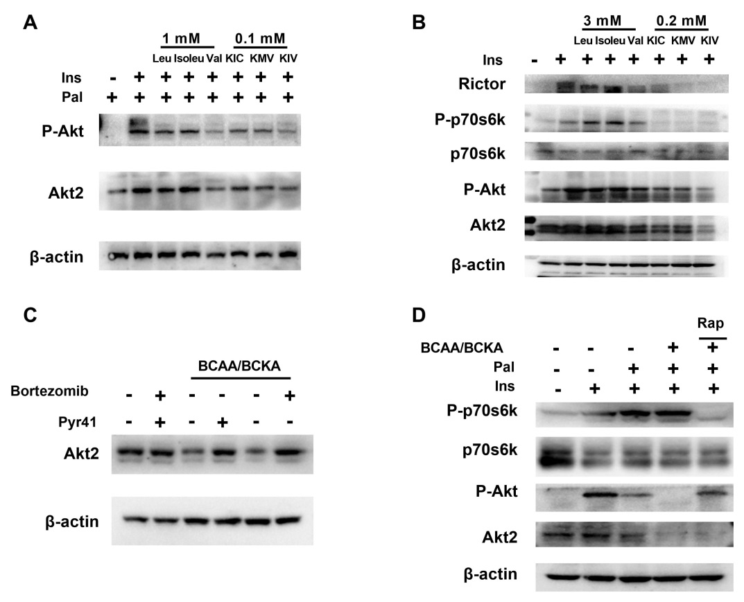
Supplementary Fig. 4 mTORC1 did not participate in BCAA/BCKA-induced Akt2 degradation in primary hepatocytes
(A) Primary hepatocytes were incubated with 3mM leucine, isoleucine and valine, or 0.2 mM KIC, KMV andKIV with 0.25 mM palmitate for 24 hour, phosphorylation and total Akt2 protein were determined; (B) Primary hepatocytes were incubated with 3mM leucine, isoleucine and valine, or 0.2 mM KIC, KMV andKIV for 24 hour, Rictor, P-p70s6k and Akt2 protein were determined after 100 nmol insulin stimulated for 30 minut, KIC, α-ketoisocaproic acid; KIV, α-ketoisovaleric acid; KMV, α-keto-β-methylvaleric acid; (C) Primary hepatocytes were incubated with 0.25 mM palmitate plus 3 mM BCAAs/0.2 mM BCKAs with or without 10 μM bortezomib or 10 μM PYR41 for 24 hours, and Akt2 protein levels were determined by immunoblotting; (D) Primary hepatocytes were incubated with 0.25 mM palmitate and 3 mM BCAAs/0.2 mM BCKAs in the presence or absence of 20 μM rapamycin for 24 hours. Cell lysates were measured by immunoblotting with antibodies against P-p70s6k, p70s6k, and Akt2.

Supplementary Fig. 5 TRAF6, SKP2, CHIP, BRCA1 and TTC3 are not responsible for BCAA/BCKA-induced Akt2 ubiquitination
(A) Primary hepatocytes were infected with adenovirus expressing either empty vector (Vec) or Rictor, and 6 hours postinfection, hepatocytes were treated with 0.25 mM palmitate with or without 3 mM BCAAs/0.2 mM BCKAs. Proteins were immunoprecipitated with antibody against Akt2 and the immunoprecipitates were incubated with antibody against TRAF6；(B) Treatments were the same as (A), and the immunoprecipitates were incubated with antibody against TTC3; (C), (D), and (E), treatments were the same as (A), and the immunoprecipitates were incubated with antibodies against SKP2, CHIP, and BRCA1, respectively.
Supplementary Fig. 6 Restored hepatic Akt2 signaling reverses glucose and insulin tolerance, pyruvate tolerance and improves blood glucose
(A) Construction of myr-Akt2 adeno associated virus; (B) Glucose tolerance tests and (C) insulin tolerance tests, *p<0.05, **p<0.01, and ***p<0.001, n=6-8, significance for individual timepoints compared to the HF/Paired group;(D) Mice were fasted overnight for 16 hours and then administered with i.p. injection of pyruvate (2 g/kg body weight), and blood glucose was detected at the indicated timepoints, *p<0.05, **p<0.01 and ***p<0.001, n=6-8, significance for individual timepoints compared to the HF/Paired group; (E) Left: fasted and refeeding blood glucose levels were detected, ** **p<0.01 and ***p<0.001, n=6-8, N. S indicates no significance compared to the corresponding fasted or refeeding status of the HF/Paired group.
Data are presented as the mean ± SD, (unpaired t test following ANOVA) compared to the HF/Paired group.

Supplementary Fig. 7 INSIG1 and INSIG2b were not evidently elevated in livers of HF/BCAA-fed mice
(A) Relative glucose production in primary hepatocytes pretreated with the indicated concentrations of Aktiviii or vehicle and then incubated for 6 hours with cAMP with or without 10 nM insulin. Akt signaling and phosphorylation level of foxo1 were determined with immunoblotting; (B) Primary hepatocytes were pretreated with the indicated concentrations of Aktviii or vehicle and incubated for 6 hours in the presence or absence of 10 nM insulin. Akt signaling, phosphorylation and total protein level of GSK3α and GSK3β, SREBP1(p), INSIG2, INSIG1, LXRα and LXRβ were determined with immunoblotting; (C) After fasting overnight with or without refeeding for 6 hours, phosphorylation level and total protein levels of Akt and GSK3α and GSK3β, SREBP1(p), INSIG2, INSIG1, LXRα and LXRβ in indicated groups were determined with immunoblotting; (D) Liver lysates from HF/Paired, HF and HF/BCAA groups under fasted-refed conditions were analyzed for insig1, and insig2b mRNA levels using PCR, data are presented as the mean ± SD, n = 6-8 per group, N. S, no significance, (unpaired t test following ANOVA) compared to the HF/Paired group or control group.; (E) After mice were given food for 16 weeks, Insig1 protein levels were determined under fasted–refeeding conditions through immunoblotting

Supplementary Fig. 8 Akt2 overexpression ameliorated plasma FFA and hepatic TG export, and adeno-associated virus serotype 9 carried GFP predominantly exhibited in the liver after 6 weeks tail vein injection.
(A) Plasma FFA levels were determined under fasted conditions, *p<0.01, n=6-8, compared to the HF/BCAA group; (B) 6 weeks after of 2 × 10 ¹¹ vector or genomes were administrated through tail vein injection, heart, skeletal muscle, kidney, adipose and liver GFP protein were determined through Western blotting; (C) Treated as (B), GFP protein were determined via immunoflourence.

