Graphic abstract
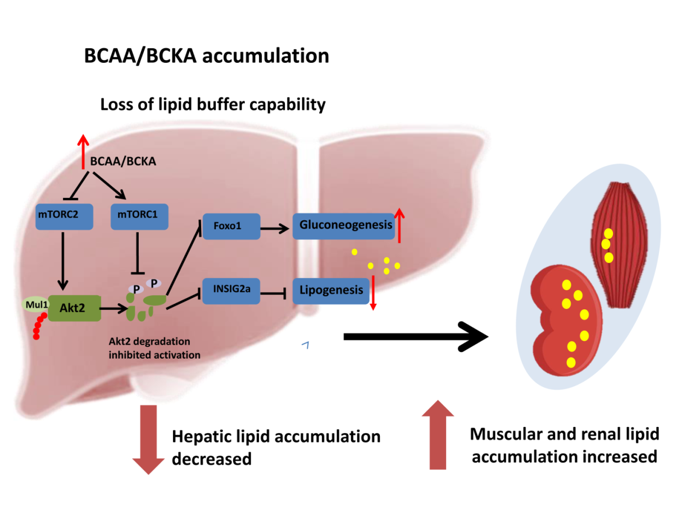
Highlight
1. BCAAs supplementation leads to severely hepatic metabolic disorder, damaged hepatic lipid buffer capability in HF diet-induced obese mice
2. BCAAs supplementation exacerbates muscle and renal ectopic lipid accumulation in HF diet-induced obese mice
3. BCAAs supplementation resulted in severe hepatic insulin resistance through deeply inhibition of Akt2 signaling in HF diet-induced obese mice
4. BCAAs supplementation suppressed Akt2 activation through mTORC1 and mTORC2-dependent pathways and promoted Akt2 ubiquitin-proteasome-dependent degradation via mTORC2
5. E3 ligase Mul1 contributed to BCAAs induced Akt2 ubiquitination and degradation

