.

Supplemental figure 1. Schema highlighting the similarities between the polyol and glucuronate-xylulose (G-X) pathway. During the polyol pathway (panel A) there are perturbations in the NADPH:NADP⁺ and NAD⁺:NADH ratios with consequential altered redox, i.e., oxidant stress. Akin to polyol pathway is G-X pathway (panel B) where myo-inositol is catabolized by myo-inositol oxygenase (MIOX), and in various subsequent steps there are perturbations in the NADPH:NADP⁺ and NAD⁺:NADH ratios with anticipated altered redox (adapted from Ref. 25 with permission).

Supplemental figure 2. Bar graph depicting serum levels of cystatin C in various strains of mice. Diabetic WT, MIOX-TG and Akita mice had elevated levels of cystatin C, suggesting renal injury in the setting of type 1 diabetes induced by the administration of streptozotocin (STZ). MIOX-KO mice had low levels of cystatin C. Interestingly, Ins2^{Akita} mice showed relatively high levels of cystatin C which decreased significantly in Ins2^{Akita}/KO mice.

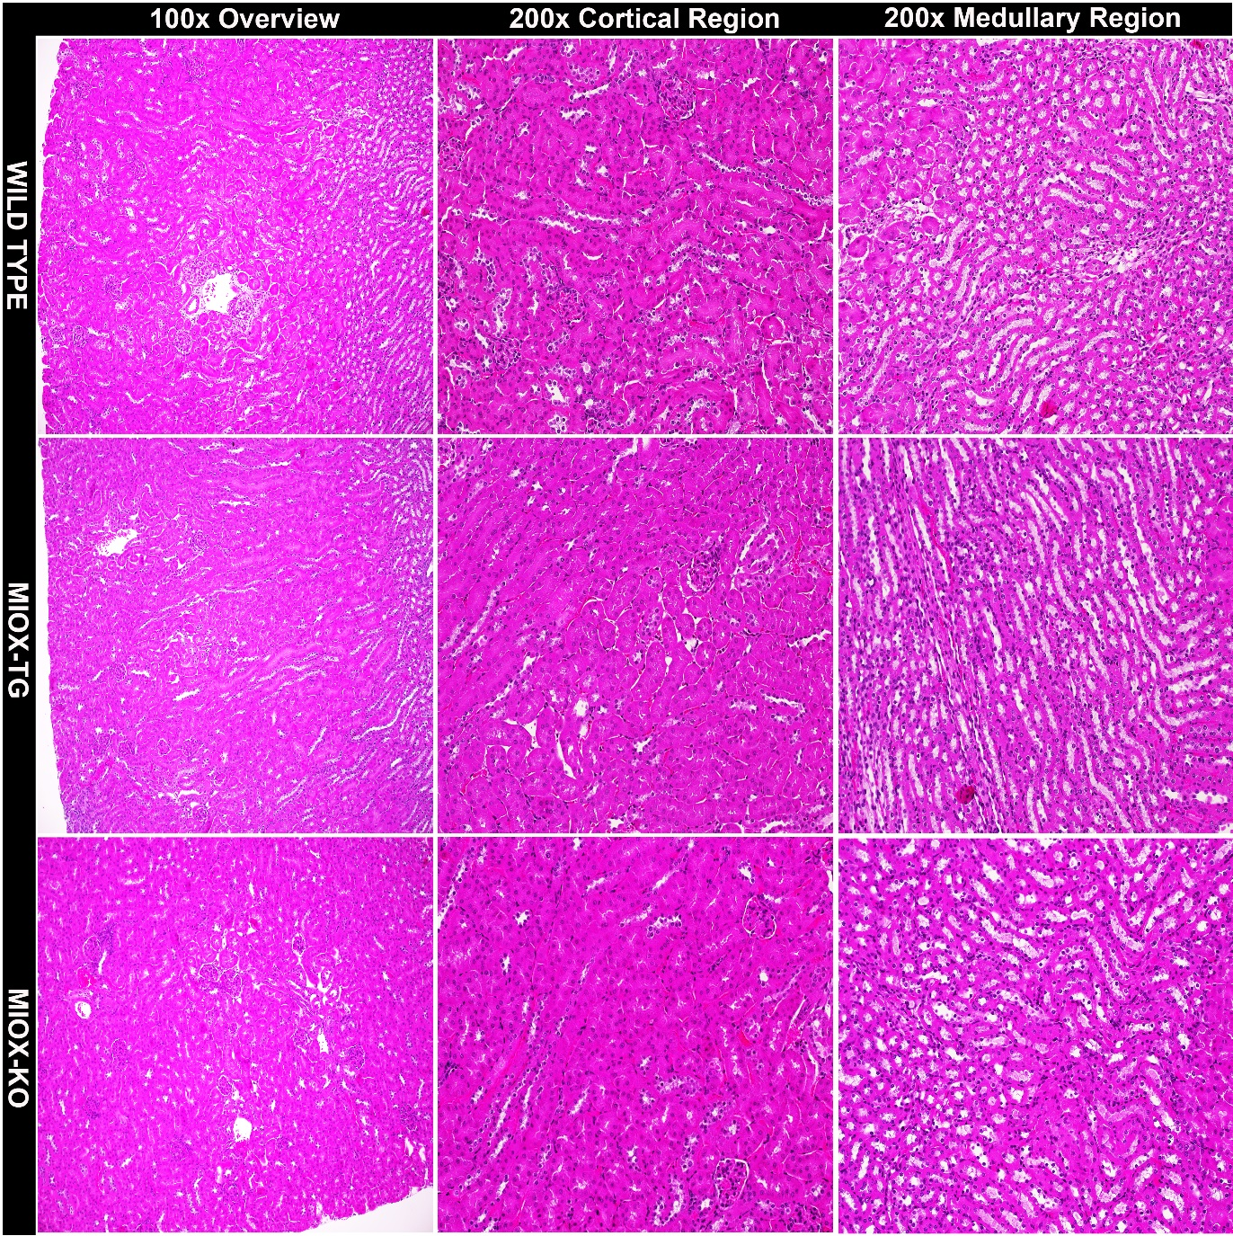

Supplemental figure 3. Light photomicrographs of kidneys harvested from various strains of mice (Wild type, MIOX-TG & MIOX-KO). No discernible morphological differences are observed in both medullary and cortical regions of the kidney at 100X or 200X magnifications among various strains of mice. (Hematoxylin & Eosin stain).

Supplemental figure 4. Western blot analyses depicting renal MIOX expression in different strains of mice (WT, MIOX-TG & MIOX-KO) in settings of diabetes. MIOX-TG mice had a remarkably increased MIOX expression following streptozotocin (STZ) administration. Ins2^{Akita} mice also had a relatively high expression of MIOX. Interestingly, MIOX-KO and Ins2^{Akita}/KO mice had no detectable expression of MIOX.

Supplemental figure 5. Schema depicting the plausible events initiated by hyperglycemia leading to accentuation of tubulo-interstitial injury with MIOX overexpression. Conceivably, XBP1:MIOX and ORE:MIOX interactions under high glucose ambience accentuate cyclical ER and oxidant stress. This combined cellular stress leads to perturbations in mitochondrial homeostasis and activation of TGF-β/Smad signaling, resulting ultimately in tubular epithelial injury and tubulo-interstitial fibrosis.

Supplementary TABLE I
Reagents | Catalogue Number | Vendor
HK-2 cells, proximal tubular cell line | CRL-2190 | ATCC
pcDNA3.1 | V79020 | Invitrogen Corporation
Anti-XBP1 antibody | ab37152 | Abcam
Anti-GRP78/BiP antibody | ab21685 | Abcam
Anti -TGF-β antibody | ab66073 | Abcam
Anti -NOX4 antibody | ab133303 | Abcam
NAD/NADH assay kit | ab65348 | Abcam
Glutathione assay kit | 703002 | Cayman Chemical
Anti-phospho-PDK1 antibody | 3061S | Cell Signaling Technology
Anti-phosphoserine-PKC substrate | 2261S | Cell Signaling Technology
Anti-Smad3 antibody | 9523S | Cell Signaling Technology
Anti-Smad4 antibody | 46535S | Cell Signaling Technology
Anti-p-samd2/3 antibody | 8828S | Cell Signaling Technology
Anti-Histone H3 antibody | 9715S | Cell Signaling Technology
Anti-Bcl2 antibody | 2876S | Cell Signaling Technology
Anti-cleaved caspase-3 antibody | 9661S | Cell Signaling Technology
Anti-Bax antibody | SC-526 | Santa Cruz Biotechnology
Anti-NOX4 antibody | SC-21860 | Santa Cruz Biotechnology
XBP1 siRNA | SC-38627 | Santa Cruz Biotechnology
siRNA universal control | SICOO1 | Origene Technologies
TO-PRO-3-iodide | T3605 | Life Technologies
Fast SYBR Green Mix | 4367659 | Life Technologies
Dulbecco’s Modified Eagle’s Medium | D5523 | Sigma
2’-7’-dichlorofluroescein diacetate | D6883 | Sigma
Dihydroethidium | D7008 | Sigma
N-acetyl cysteine | A7250 | Sigma
Anti-β-actin antibody | A5441 | Sigma
Collagen1 antibody | C2456 | Sigma
Fibronectin antibody | F3648 | Sigma
ChIP assay kit | 17-295 | Millipore
LipofectamineTM 2000 | 11668027 | Thermo Fischer Scientific
QuantiChrom™ Creatinine Assay Kit | DICT-500 | Bio-assay System
Mouse KIM1 ELISA Kit | ab119596 | Abcam
Mouse/Rat Cystatin C Quantikine ELISA Kit | MSCTC0 | R & D Systems
Albuwell M Test Kit | 1011 | Exocell
Creatinine Companion | 1012 | Exocell
QuantiChrom™ Urea Assay Kit | DIUR-100 | Bio-assay System
myo-Inositol assay kit | K-INOSL | Megazyme
Accu-Check Glucometer | 06988580001 | Aviva Plus
Anti-rabbit IgG-HRP antibody | A0545 | Sigma
Anti -Mouse IgG-HRP antibody | A9917 | Sigma
Anti -Rabbit IgG-FITC antibody | F9887 | Sigma
Anti -Mouse IgG-FITC antibody | F0257 | Sigma
Anti-MIOX antibody | - | Ref. # 26 of the manuscript

